

**SAP HANA Technical Academy** – **Hands-on Workshop Labs**

**Review for GitHub Example**

Document Version 2017 -1.0 – February 06, 2017

|  |  |  |  |
| --- | --- | --- | --- |
| **Date** | **Author** | **Notes** | **Revision** |
| 06 February 2017 | Annette Nash / Lategan Coetzer | Original Document | 1.0 |
|  |  |  |  |

**SAP STATEMENT OF CONFIDENTIALITY AND EXCEPTIONS**

The contents of this document shall remain the confidential property of SAP and may not be communicated to any other party without the prior written approval of SAP. This document must not be reproduced in whole or in part. It must not be used other than for evaluation purposes only, except with the prior written consent of SAP and then only on condition that SAP’s and any other copyright notices are included in such reproduction. No information as to the contents or subject matter of this proposal or any part shall be given or communicated in any manner whatsoever to any third party without the prior written consent of SAP. The furnishing of this document is subject to contract and shall not be construed as an offer or as constituting a binding agreement on the part of SAP to enter into any relationship. SAP provides this document as guidance only to estimate costs and time-scales of the predicted delivery project. This will be subject to confirmation prior to any contractual or delivery commitment by SAP. SAP warrants that to the best of its knowledge those who prepared this material have taken all reasonable care in preparing it and believe its contents to be true as at the date of this document. SAP cannot however warrant the truth of matters outside of its control and accordingly does not warrant the truth of all statements set out in this document to extent that such statements derive from facts and matters supplied by other persons to SAP. The statements in this document are qualified accordingly.

**BW/4HANA Hands-on Workshop**

Contents

**BW/4HANA Hands-on Workshop** 4

SAP HANA Introduction 6

What is SAP HANA database? 6

About SAP HANA studio 9

Basic Navigation in HANA Studio 9

**BW Modeling Tools in HANA Studio** 9

**HANA Modeling Tools in HANA Studio** 10

SAP BW/4HANA Introduction 11

Accessing the Hands-on Labs 12

Field Based Modeling 14

Overview 14

Hands-on Labs 14

Field Based Modeling - HANA Table as a Data Source 15

**Create an InfoArea** 15

**Create new Data Source** 16

**Create new Advanced DSO (ADSO)** 20

**Create new Data Flow** 26

**Create new DTP to load data** 34

**View Data** 37

Field Based Modeling - Excel as a Data Source 40

**Create New Data Source** 40

**Create a new advanced DSO** 44

**Create New Data Flow** 46

**Create new DTP to load data** 54

**View Data** 58

Composite Provider 61

Overview 61

Create New Composite Provider 61

SAP Business Objects Lumira 68

Overview 68

Connect to Data 68

# 

Review for GitHub presentation

# SAP HANA Introduction

SAP HANA is a modern platform for real-time analytics and applications. It enables organizations to analyze business operations based on large volume and variety of detailed data in real-time, without any delays.

HANA offers endless opportunity for business innovation within all industries and lines of business. The following three dimensions represent a model for understanding the potential of HANA:

* **Real-time information and insight into organizational data**Gain immediate insight from operational or strategic data despite large data volumes, without information delays caused by nightly batch processes.
* **Real-time simulation & foresight to optimize business processes**Simulate and foresee business situations like demand patterns or cash exposures based on current business conditions plus historical data and trends.
* **Real-time sense & response to capitalize on streaming data & events**  
  Process real-time streaming data like energy consumption with [smart meters](https://www.experiencesaphana.com/videos/1134) for driving immediate business decisions in an automated fashion.

## What is SAP HANA database?

The SAP HANA database is a relational database that has been optimized to leverage state of the art hardware. It provides all of the SQL features of a standard relational database along with a feature rich set of analytical capabilities and an SAP specific programming language for stored procedures called SQL Script. With these facilities the SAP HANA database is capable of embedding application logic within the database itself. This allows complex queries to be executed directly inside the database, thus reducing the requirement of data transfer to and from the database. This enables SAP HANA based applications to process vast amounts of data whilst operating in a responsive, real-time manner.

From the administrators perspective the SAP HANA Database is conceptually about leveraging modern hardware system landscapes to increase database performance and reliability. Traditionally databases have been designed to operate in a situation where there are limited memory and CPU resources. Currently however, servers can provide in excess of 1TB of memory and up to 80 CPU cores on a single system.

To better understand how the SAP HANA database improves on the traditional database concepts, in the next section we will compare and contrast the two approaches to database systems.

**Impact of Modern Hardware on Database System Architecture**

Historically database systems were designed to perform well on computer systems with limited RAM, this had the effect that slow disk I/O was the main bottleneck in data throughput. Consequently the architecture of these systems was designed with a focus on optimizing disk access, e. g. by minimizing the number of disk blocks (or pages) to be read into main memory when processing a query.

Computer architecture has changed in recent years. Now multi-core CPUs (multiple CPUs on one chip or in one package) are standard, with fast communication between processor cores enabling parallel processing. Main memory is no-longer a limited resource, modern servers can have 1 TB of system memory and this allows complete databases to be held in RAM. Currently server processors have up to 80 cores, and 128 cores will soon be available. With the increasing number of cores, CPUs are able to process increased data per time interval. This shifts the performance bottleneck from disk I/O to the data transfer between CPU cache and main memory (see figure. 1).

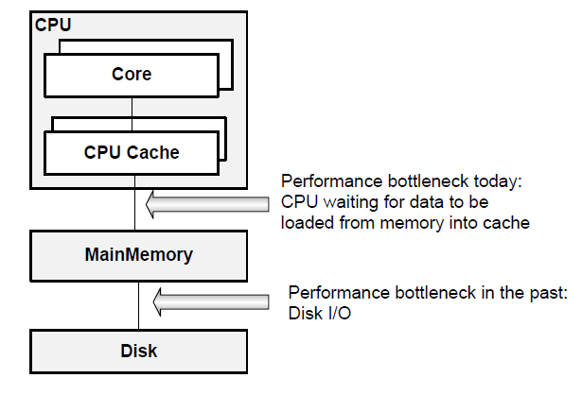

Figure 1: Hardware architecture: Current and past performance bottlenecks

**Modern Database for Modern Hardware**

From the discussion above it is apparent that traditional databases might not use current hardware most efficiently. So, what are the ideal characteristics of a database systems running on modern hardware?

**In-memory database.** All relevant data should be available in main memory, which characteristically avoids the performance penalty of disk I/O. To use the advantages of in-memory computation a cache-conscious implementation of data structures and algorithms is necessary.

**Support for parallel execution.** Higher CPU execution speeds are currently achieved by adding more cores to a CPU package. Multiple CPUs call for new parallel algorithms to be used in databases in order to fully utilize the computing resources available. SAP HANA addresses these requirements, by storing all of its data in RAM and also enabling queries to be split and optimized across multiple CPU cores and multiple SAP HANA servers.

**Disk Storage.** Disk storage is still required to ensure the ability to restart in case of power failure and for permanent persistency. This is not a performance issue however, as the required disk write operations can happen asynchronously as a background task. More over SAP HANA database tries to get the performance optimum from the different storage types, like main memory, solid state disks (SSD) and traditional mechanical hard drives (HDD).

## About SAP HANA studio

The SAP HANA studio provides an administration console, an information modeler and a lifecycle management perspective. The SAP HANA studio runs on the Eclipse platform (For more information, see also http://www.eclipse.org).

The administration console of the SAP HANA studio allows technical users to manage the SAP HANA database as well as to create and manage user authorizations.

The information modeler allows technical users to create new or modify existing models of data.

## **Basic Navigation in HANA Studio**

To open HANA Studio, click the HANA Studio icon on the bottom menu.



### **BW Modeling Tools in HANA Studio**

Select the **BW Modelling** perspective (step 1), then expand BW Project **B01_800_hta01_en** (step 2).

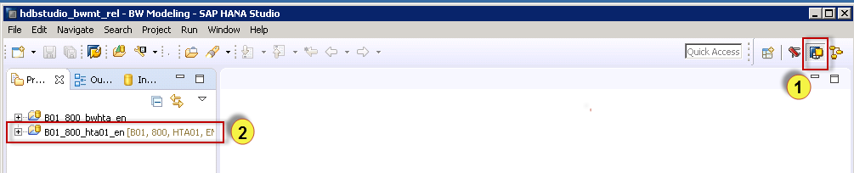

Enter the password **Welcome01.**

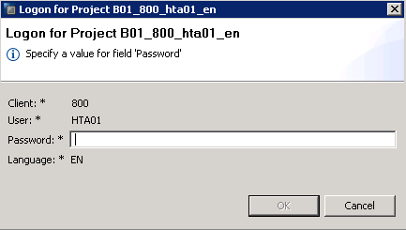

In the BW Project you will see the available BW content.

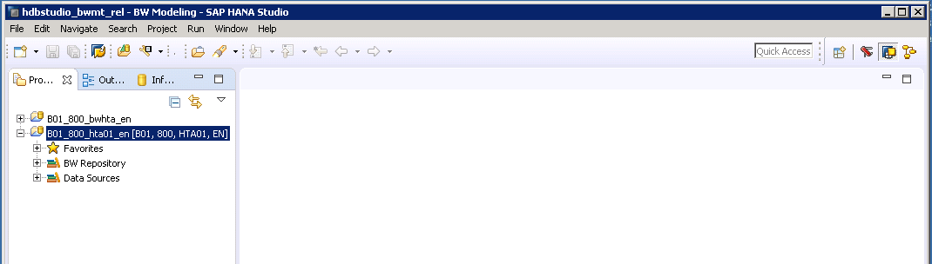

### **HANA Modeling Tools in HANA Studio**

Open the **HANA Modeler** perspective in the SAP HANA Studio (step 1), then expand the **HDB (BWHTA)** system to access the content in HANA Studio.

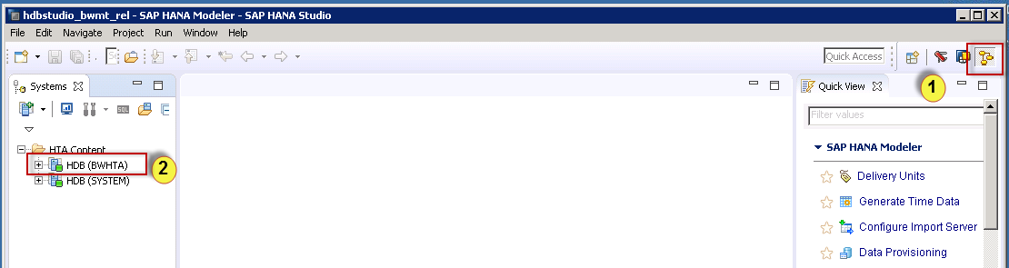

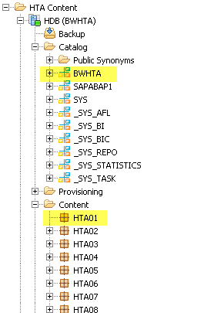

# SAP BW/4HANA Introduction

SAP BW/4HANA is SAP’s next generation data warehouse solution.

It is a new product (not a legal successor of any existing SAP Business Warehouse solution), built entirely on one of the most advanced in-memory platforms today – SAP HANA.

It provides a simple set of objects that is well suited for modelling an agile and flexible layered architecture of a modern data warehouse.

SAP BW/4HANA manages all sorts of data, whether from SAP applications or other systems, structured or unstructured, and allows accessing of all models through an open SQL interface.

SAP BW/4HANA comes with state of the art user interfaces for administrators, developers, and end users as well as completely SAP HANA-optimized processes that let you leverage huge amounts of data in real time for competitive advantage.

The core functionality of SAP BW is preserved and the transition to SAP BW/4HANA can be compared with the transition of SAP Business Suite to SAP S/4HANA. As part of this transition, SAP BW/4HANA will drastically reduce the number of data objects to be stored and maintained. All future innovations will take place in SAP BW/4HANA.

Prior releases of SAP BW powered by SAP HANA will move into maintenance, receiving little development or new functionality moving forward.

# Accessing the Hands-on Labs

Your Instructor will provide connection and environment information. Our labs are being run from the Amazon Web Services (AWS). It is comprised of two images:

* A Windows-based image that contains the client tools used during the workshop labs. (We will only be connecting to this image directly today)
* A Linux-based image that houses the SAP HANA database environment.

Open the Remote Desktop Connection program (In Windows 7 go to Start 🡪 All Programs 🡪 Accessories 🡪 Remote Desktop Connection).

Enter the **IP Address** provided by the instructor (it will be in the format as shown below) and then click **Connect**.

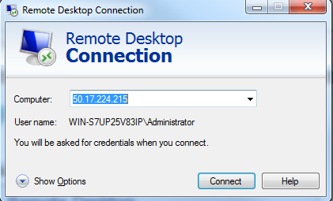

When prompted, log in as **Administrator** with a password of **TAcademy_2016.**

Accept the certificate warnings.

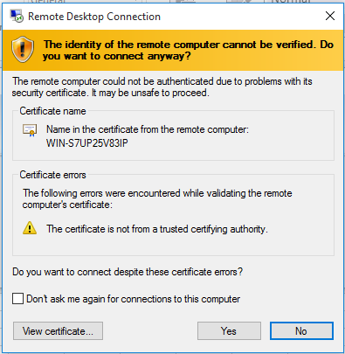

You will then be on the Windows client image as shown below.

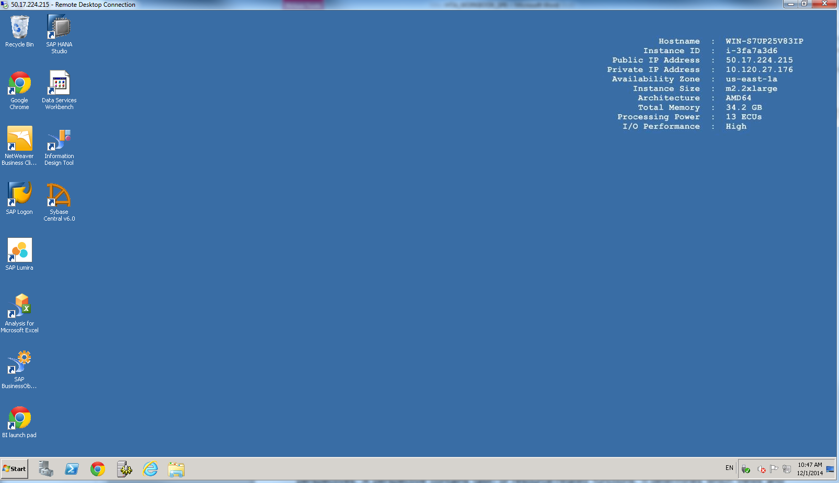

# Field Based Modeling

## Overview

The purpose of the hands on exercises are to give you an opportunity to build and experience a few of the modeling capabilities delivered by SAP BW/4HANA.

We will focus mainly on two scenarios:

* Creating an Advanced DataStore based on a HANA table as a Data Source for your Planning Data.
* Creating an Advanced DataStore based on an Excel Flat file as a Data Source for your Actual Data.

At the conclusion of this exercise, you will be able to:

* Navigate and use the new BW modelling tools in SAP HANA Studio.
* Create an Info Area.
* Create an Advanced DataStore Object.
* Identify, Create and Manage the components of a Data Flow.
* Create a Composite Provider.
* Connect Lumira to SAP HANA.

## Hands-on Labs

If you are not currently in the BW Modeling Tool in HANA Studio go to:

Open HANA Studio, click the HANA Studio icon on the bottom menu.



Select the **BW Modelling** perspective (step 1), then expand BW Project **B01_800_hta01_en** (step 2).



Enter the password **Welcome01.**



## Field Based Modeling - HANA Table as a Data Source

### **Create an InfoArea**

Right Click on the **BW Repository** and choose **New -> InfoArea.**

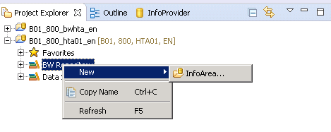

Enter the technical name **ZHTA01** and description **FM Field Based Modeling.**

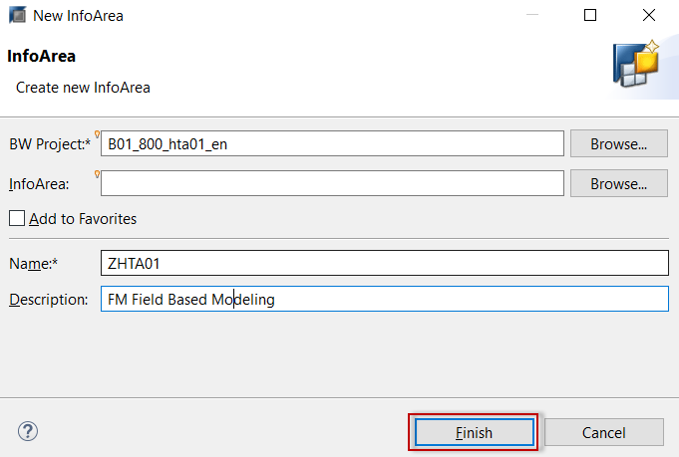

Click **Finish.**

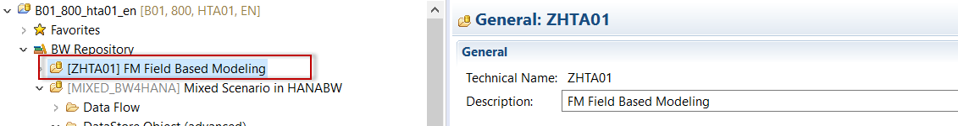

### **Create new Data Source**

Expand **Data Sources,** then expand the **HANADB** folder.

Expand **B4HDB** Source System

The HANA Source System was already created and pointing to the **BWHTA schema** where the planning table resides.

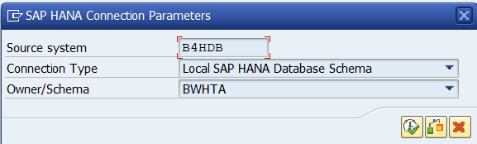

Right click on **NODESNOTCONNECTED**, select **New -> DataSource**

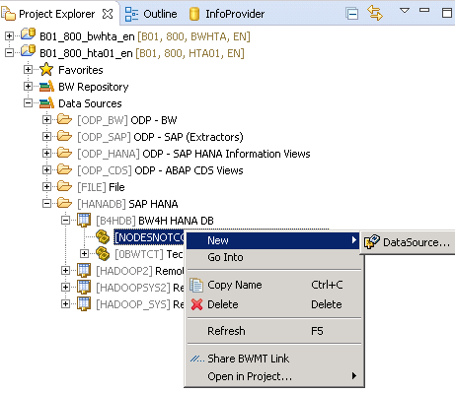

Enter the Technical Name **ZDS_HTA1** and Description **Data Source for Advance DSO Planned Data** (step 1)

Select DataSource Type as **Transactional Data** from pulldown list (step 2).

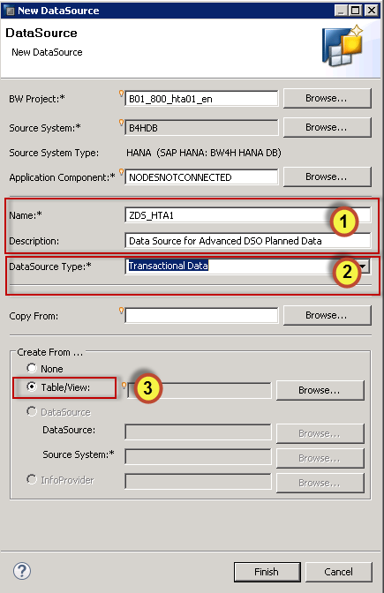

Select the **Table / View** radio button (step 3) and **Browse** for the HANA planning table.

Enter **HTA\*** in the search.

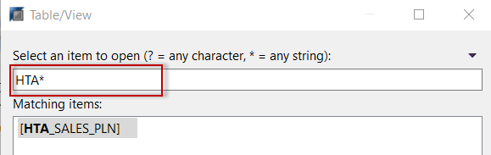

Select HANA table **HTA_SALES_PLN** and click **OK**.

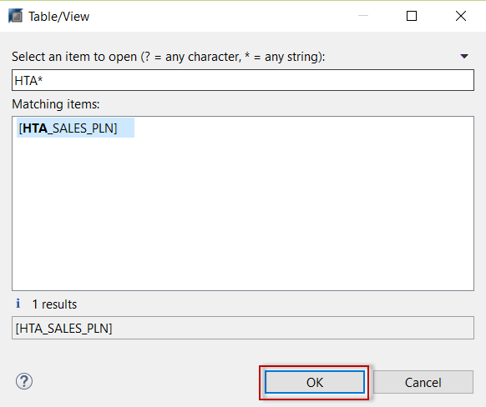

Click **Finish.**

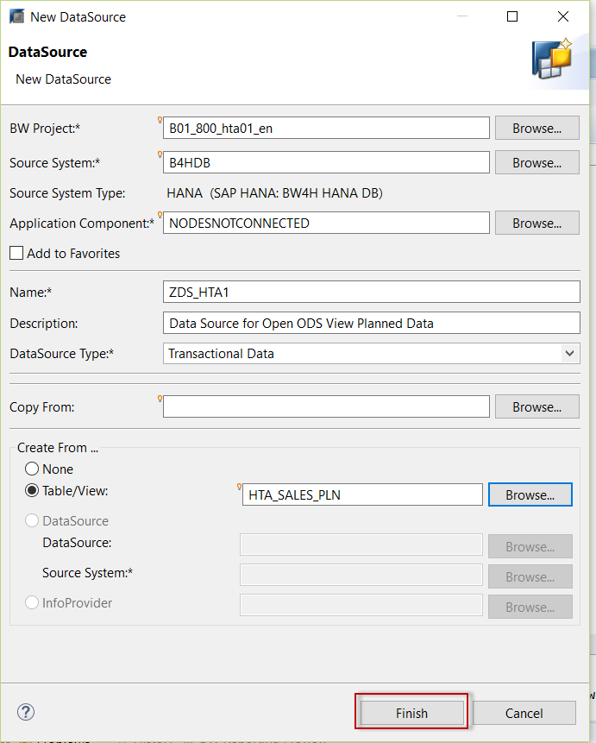

**Activate** the Data Source.

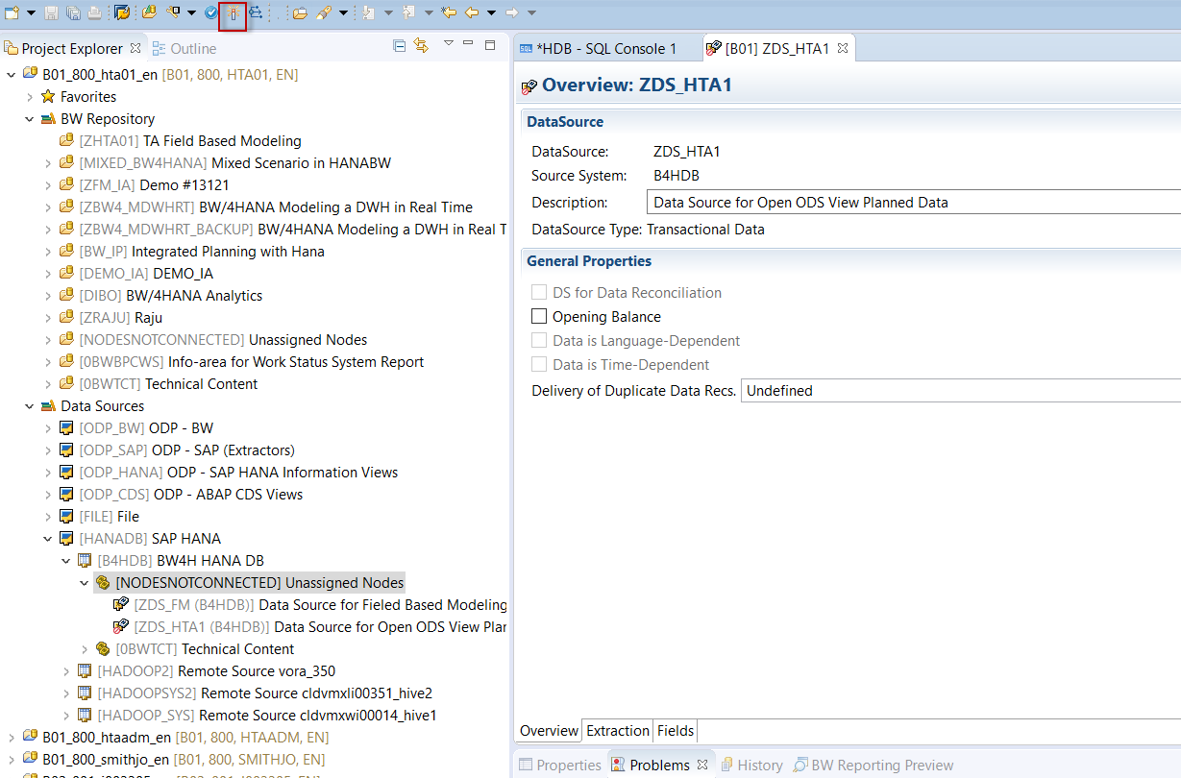

Select the **Fields** tab to view to view the source fields.

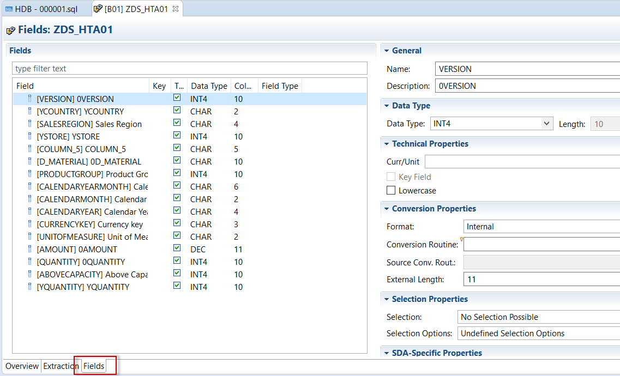

### **Create new Advanced DSO (ADSO)**

Right click on **ZHTA01** InfoArea and select **New -> DataStore Object (advanced)**

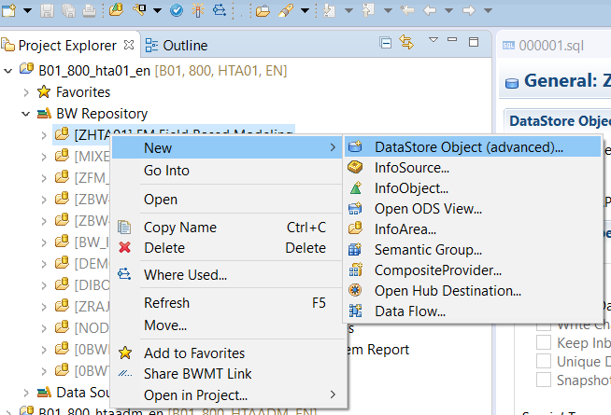

Enter the Technical Name **ZADSOHTA1** and Description **FM Planning Data** (step 1).

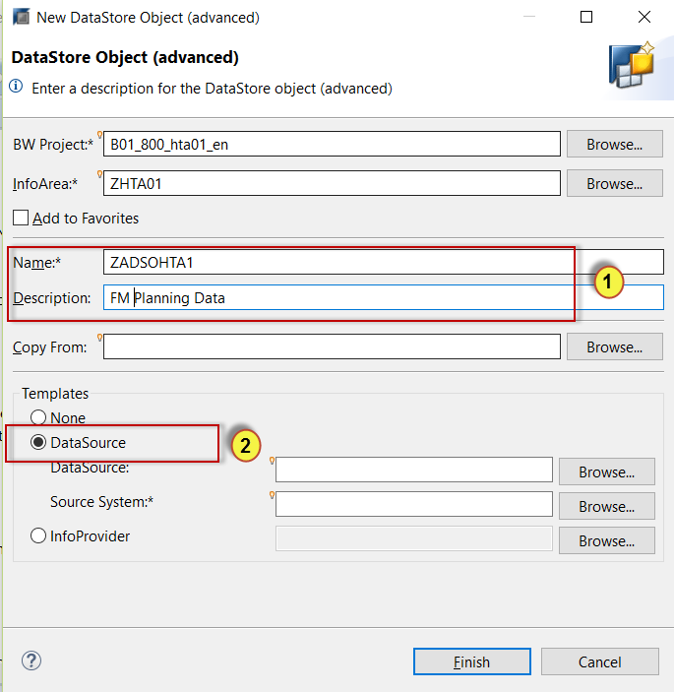

Select the **DataSource** radio button (step 2) and **Browse** for the HANA planning table.

Enter **ZDS_\*** in the search.

Select DataSource **ZDS_HTA1** and click **OK**.

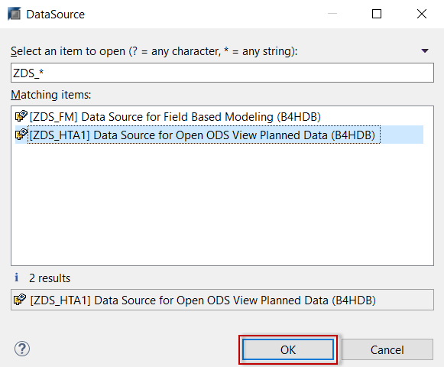

Click **Finish.**

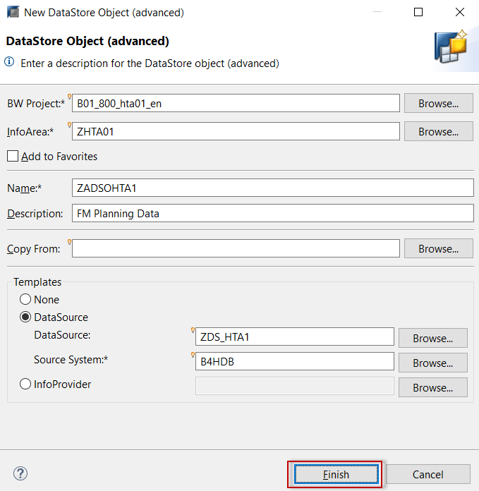

Select the **General** Tab to view Modeling Properties.

Select the **Activate** **Data** (Allow use of Keys) and **Write Change Log** (Allow deletion of Active Requests from Change Log) options.

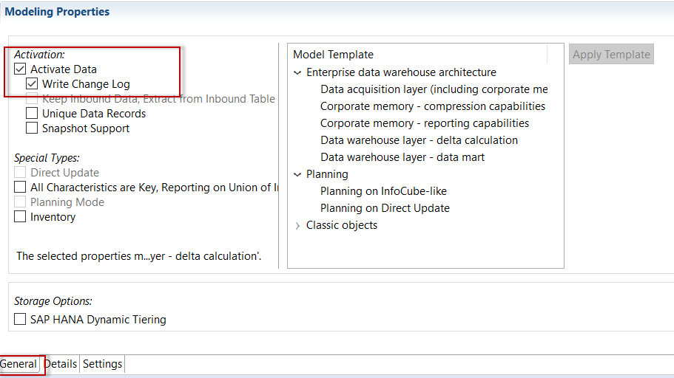

Select the **Detail** Tab to view the Non-Key Fields

Click **Manage Keys …**

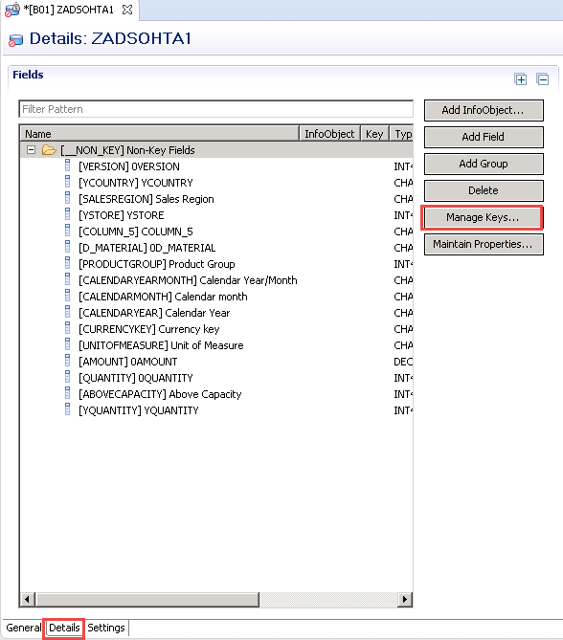

Select the following fields:

**0VERSION  
YCOUNTRY  
YSTORE  
D_MATERIAL  
CALENDARYEARMONTH**

Click **Add**

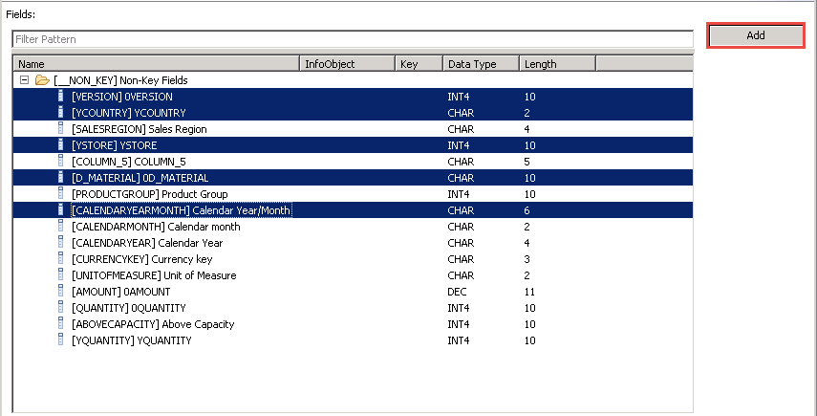

Click **OK**

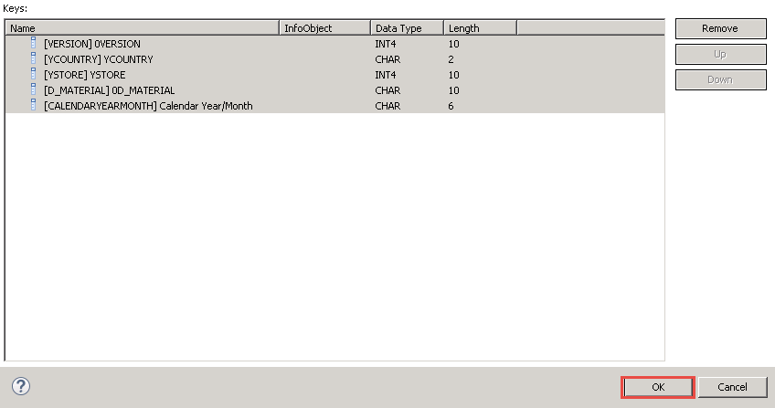

Click the **Add Group** button

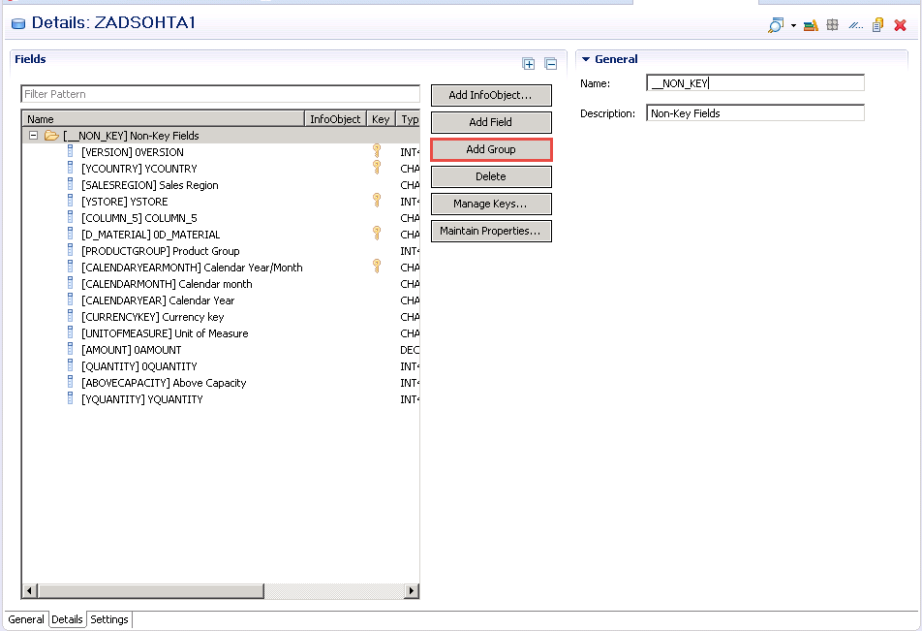

Create a group called **KEYFIGURES** with the description **Key Figures** (Step 1)

Drag and Drop the following fields from the **Non-Key fields** group to the **Key Figures** group (step 2)

**Unit of Measure**  
**Currency Key**  
**0QUANTITY**  
**Above Capacity**  
**0AMOUNT**  
**YQUANTITY**

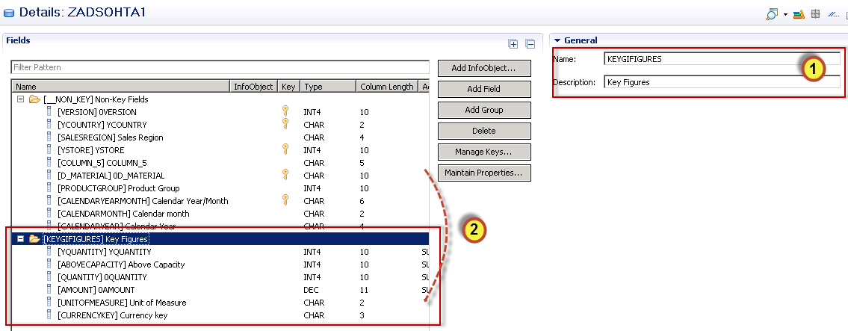

For each of the following key figures, set the Aggregation to **SUM**

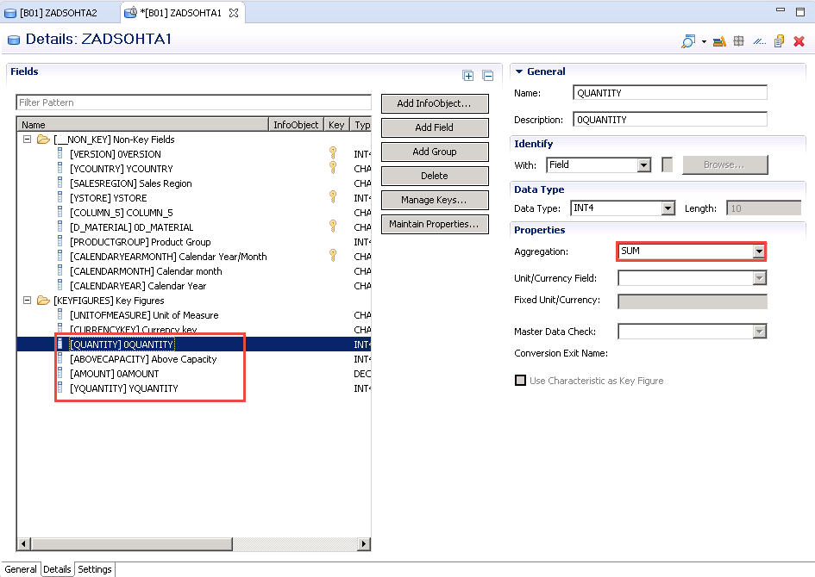

**Activate** the DataStore Object (advanced)

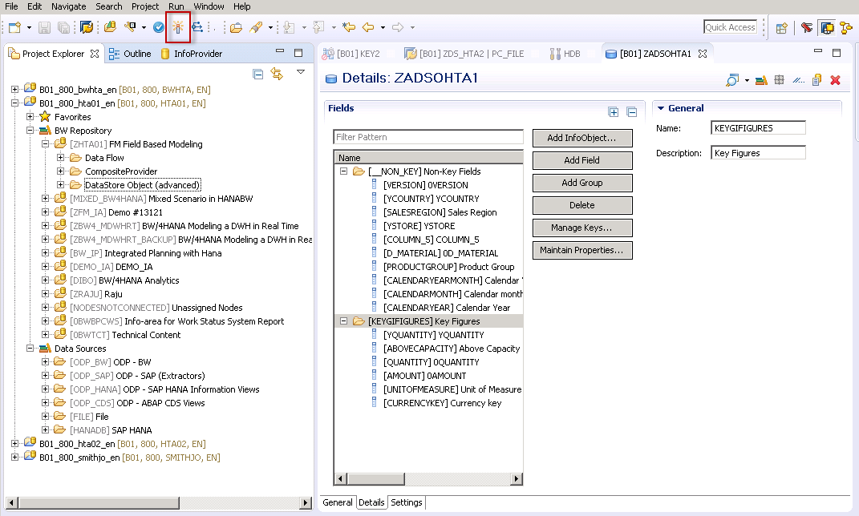

### **Create new Data Flow**

Right click on **ZHTA01** InfoArea and select **New -> Data Flow**

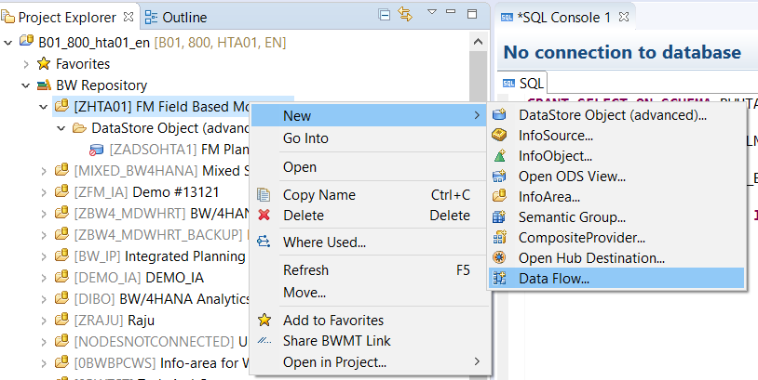

Enter the Technical Name **ZDF_HTA1** and Description **FM Data Flow for Planning Data** (step 1).

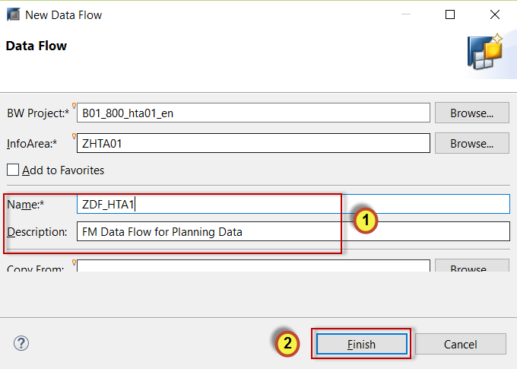

Click **Finish (**step 2).

First we will select the target for our Data Flow.

Select the **DataStore** **Object (advanced)** and drop it on the screen.

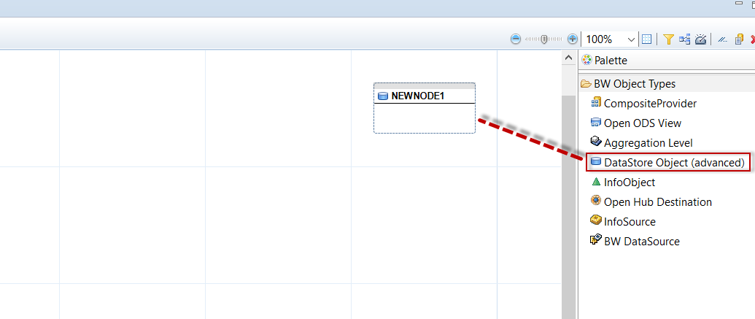

Right click on the object and select **Add Object**

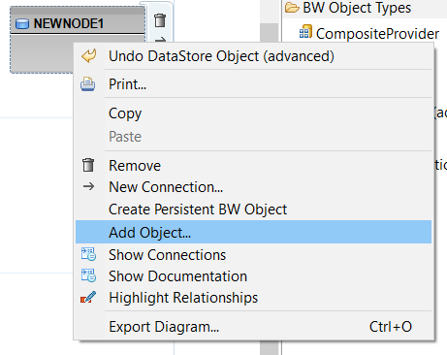

Enter **ZADSO** in the search (step 1) and select Advanced DSO **ZADSOHTA1** (step 2).

Click **OK** (step 3).

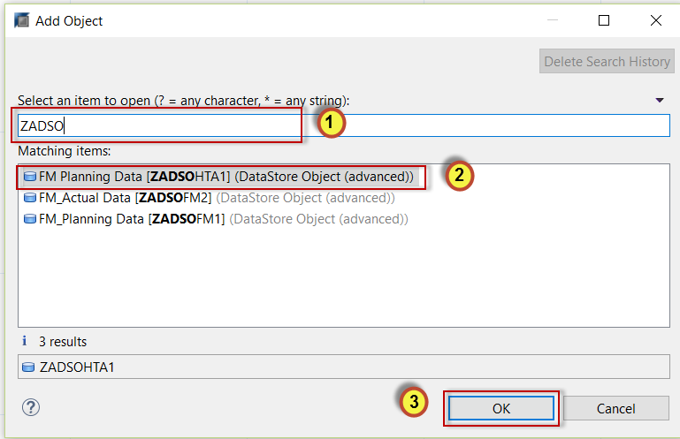

Next we will select the Data Source.

Select **DataSoure** and drop it on the screen.

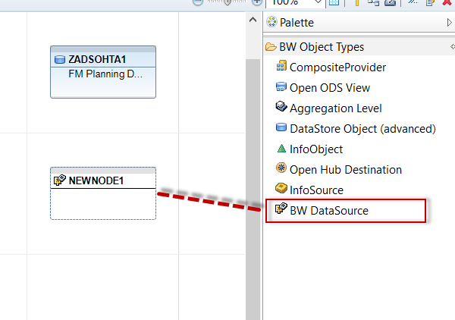

Right click on the object and select **Add Object**

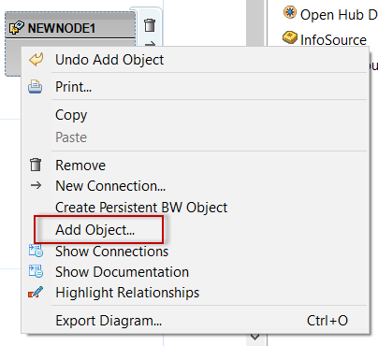

Enter **ZDS_** in the search (step 1) and select DataSource **ZDS_HTA1** (step 2).

Click **OK** (step 3).

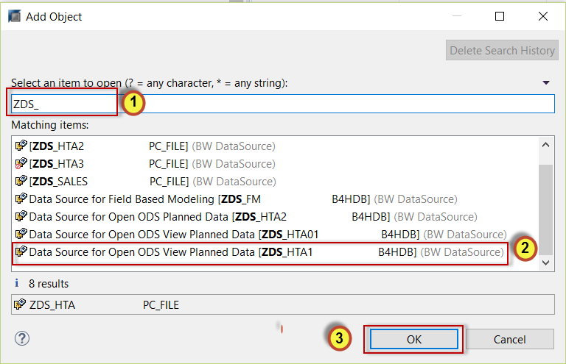

Your Data Flow should look as follows:

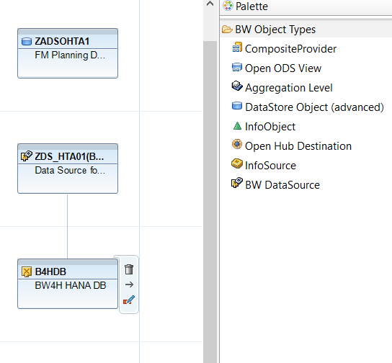

Next we will **link** the source to the target and **create** our transformation.

Hover your cursor over the Data Source **Connection Arrow** (step 1)and drag connection to the Advanced **DSO ZADSOHTA1** (step 2).

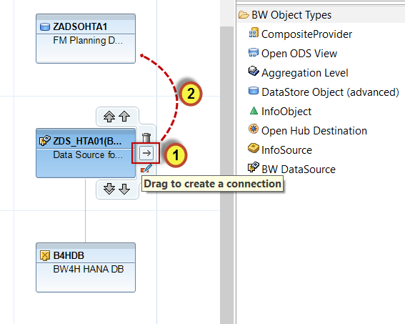

To create the Transformation r-click on ADSO **ZADSOHTA1** (step 1), select **Transformations** (step 2)and **Create transformation RSDS_ZDS_HTA01** (step 3).

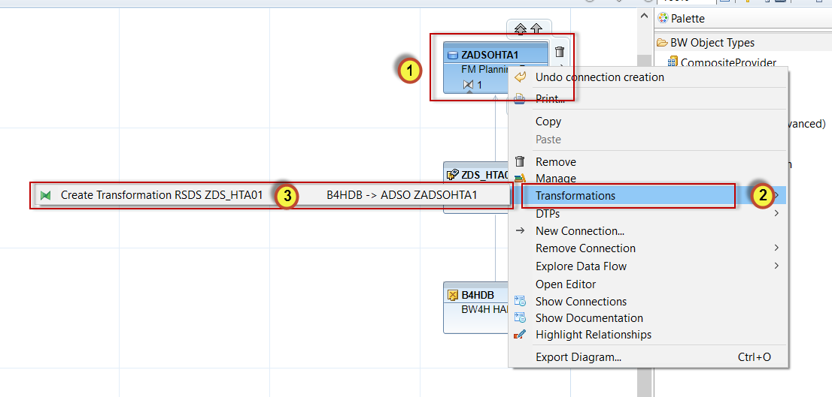

Click on **Create Transformation Check.**

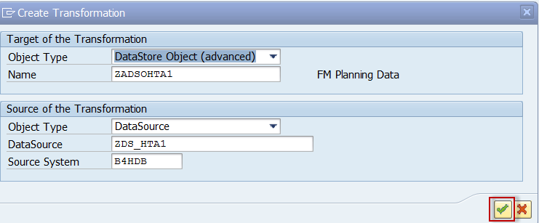

There are no duplicate records in the HANA table so we can keep the proposed selection and Aggregation.

Click **Activate.**

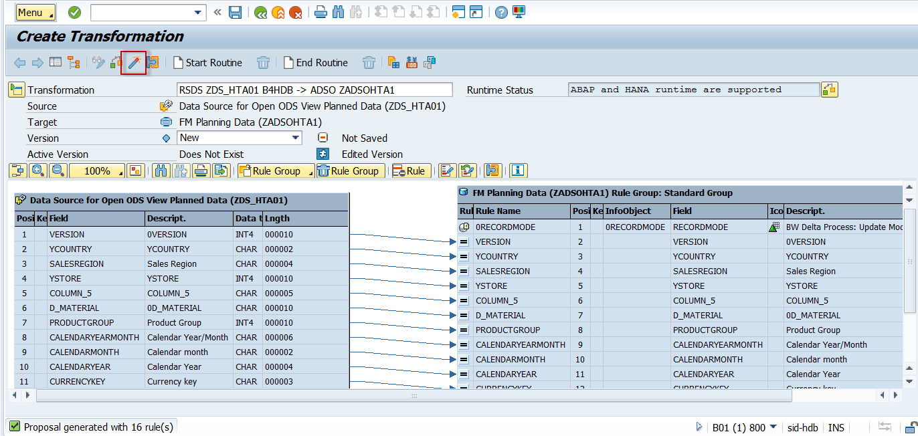

Click **Continue** on the Log Display

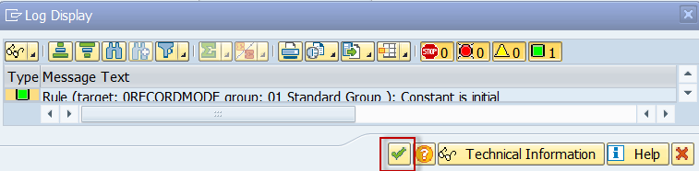

Click **Back.**

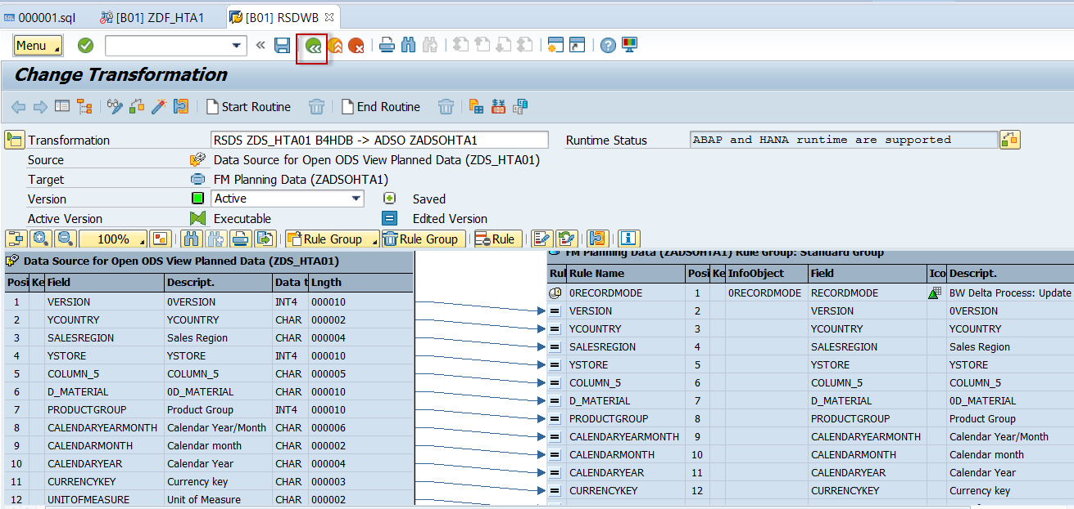

Select the **Data Flow** tab again.

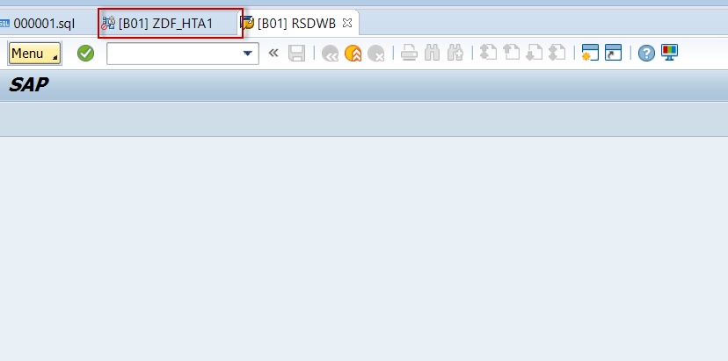

The transformation should now be green and active.

The **1** indicates the number of Transformations.

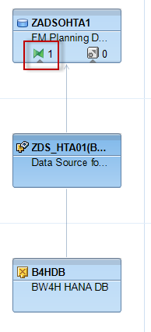

### **Create new DTP to load data**

From the Data Flow Tab.

R-click on ADSO **ZADSOHTA1** (step 1), select **DTPs** (step 2) and **Create DTP** (step 3).

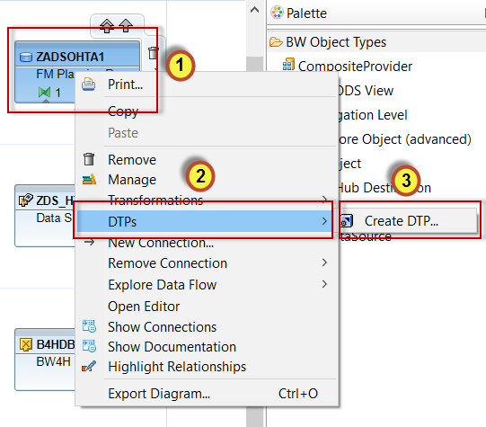

No Need to enter anything in the filter text.

Click on ADSO **ZADSOHTA1** and click **OK.**

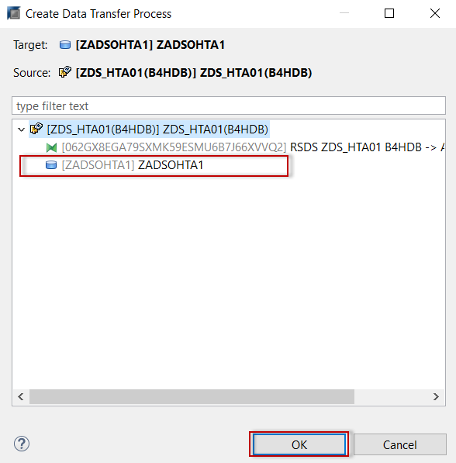

Click **Continue** to continue creating the DTP.

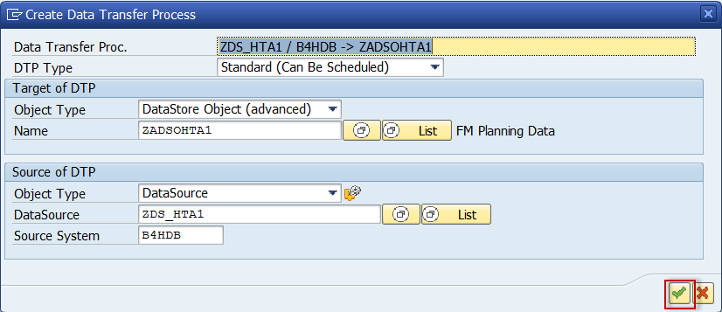

Keep the DTP settings, click on **Check** (step 1) and **Activate** (step 2).

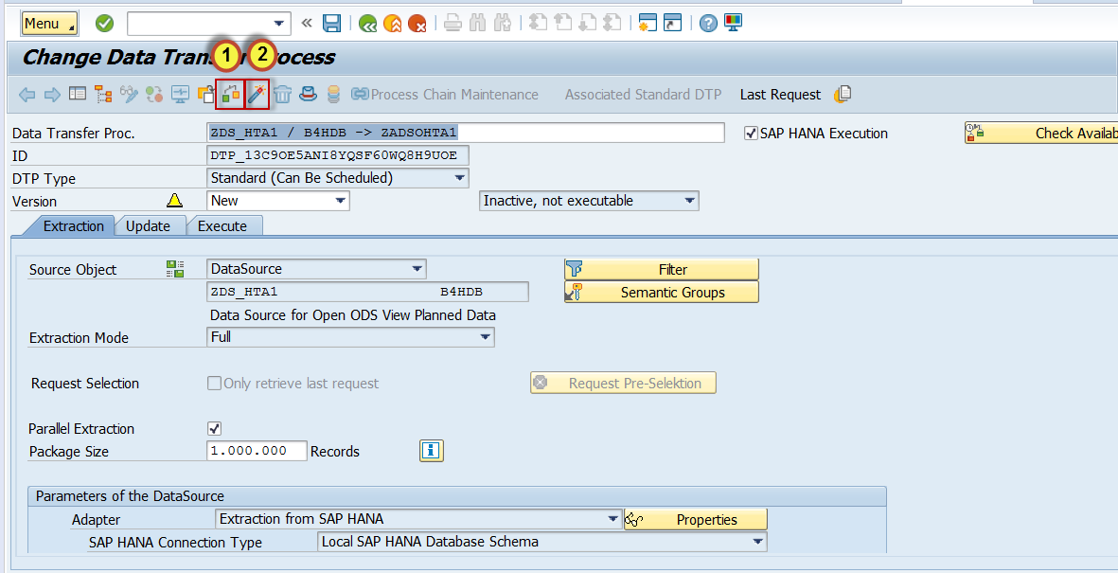

Activate the whole Data Flow.

Click on the **Data Flow** tab (step1) and **Activate** the Data Flow (step 2).

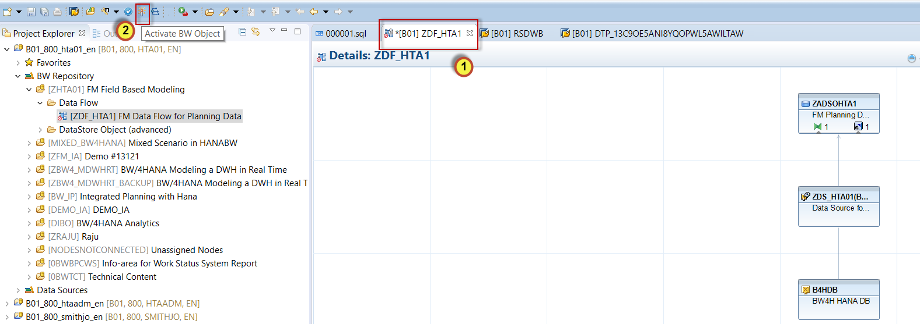

Now we will load data to the ADSO.

Go back to the **DTP** tab (step 1), select the **Execute tab** (step 2) and **Execute** (step 3) the DTP in the background.

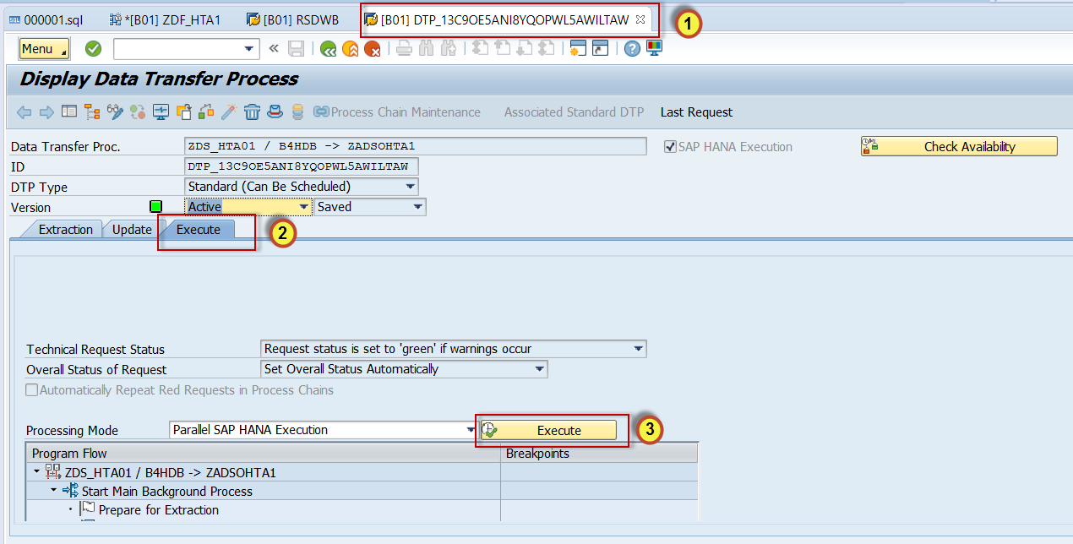

One data package with 99,999 records were processed.

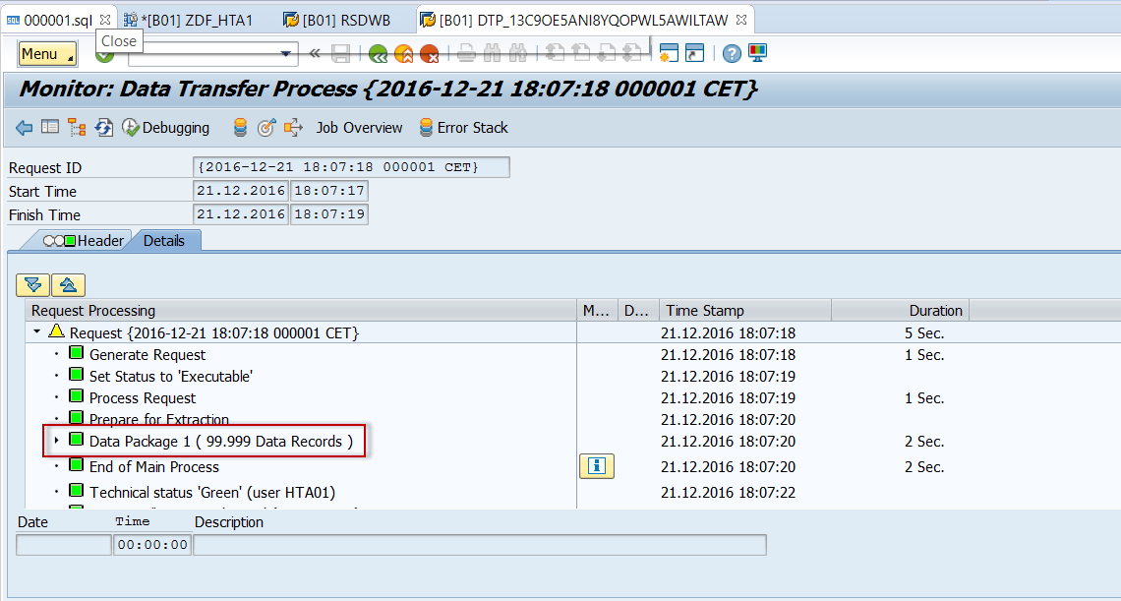

### **View Data**

To view your records go back to the **Data Flow tab** (step 1), right-click on ADSO **ZADSOHTA1** (step 2) and select **Manage** (step 3).

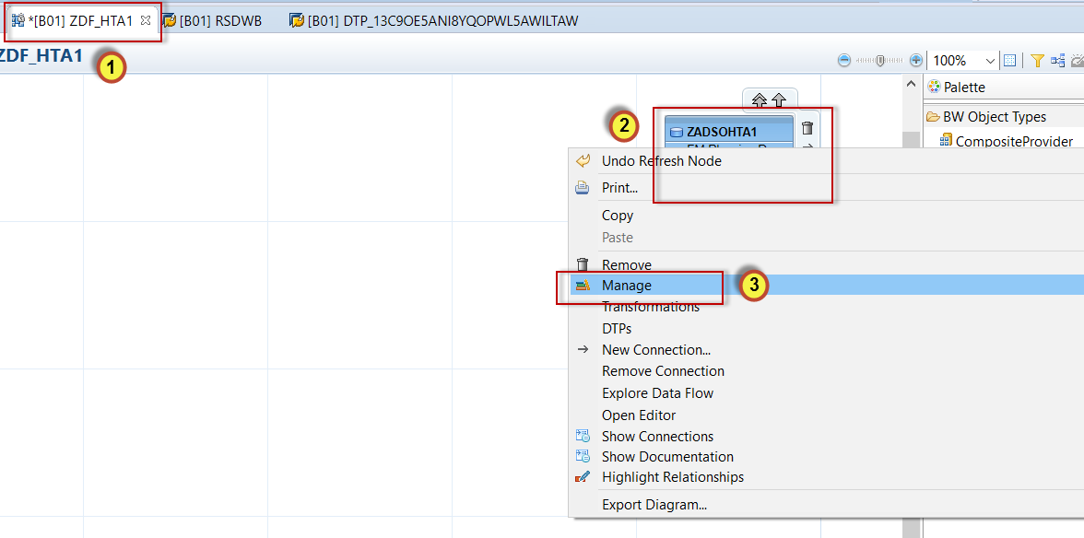

Right-click on request and **Activate** first.

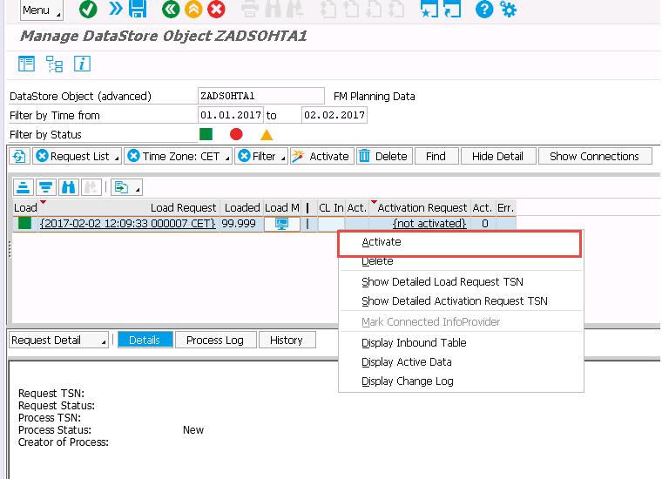

Right-click on the **Load Request** (step 1) and **Display Active Data** (step 2).

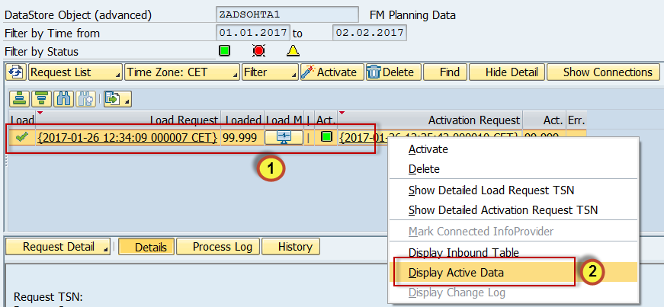

A selection screen will appear. Click **Execute** and now you can view your data.

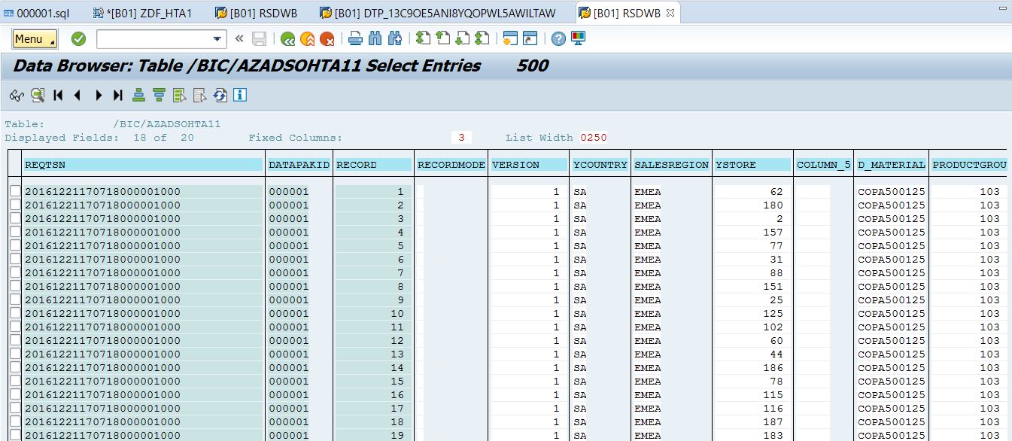

Close all the tab, select **File** (step 1), and select **Close All** (step 2).

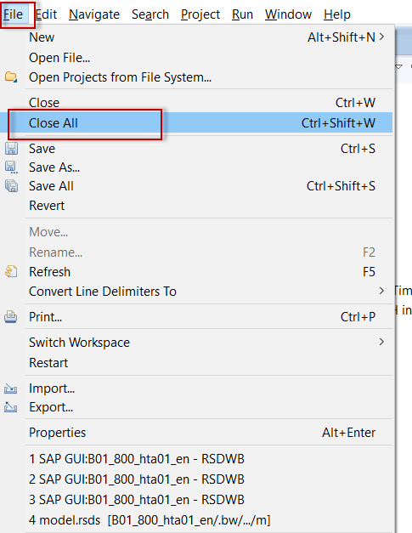

## Field Based Modeling - Excel as a Data Source

### **Create New Data Source**

Expand **Data Sources** -> **FILE** -> **PC_FILE**, then right–click **NODESNOTCONNECTED** and choose **New -> DataSource…**

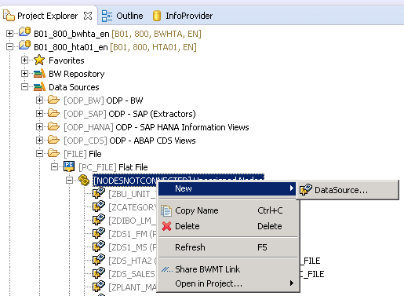

Enter the DataSource **ZDS_HTA2**, the Source System **PC_FILE** and the DataSource Data Type **Transaction Data**

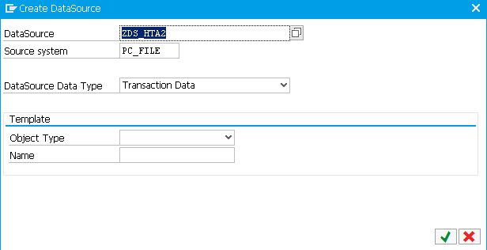

Click the **Green check**. The following screen is displayed.

On the **General Info** tab, enter **DS for ADSO Act Data** as the Short Description and **Data Source for Advanced DSO Actual Data** as the Medium and Long Description.

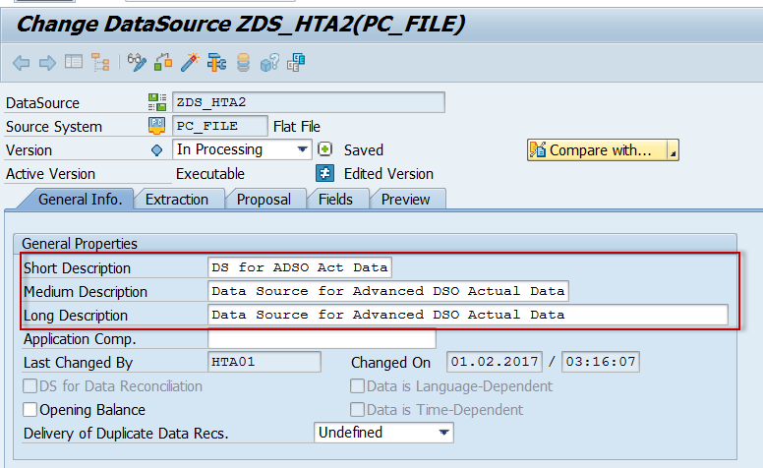

Click the **Extraction** tab and from the **Adapter** drop-down choose **Load Microsoft Excel File (XLS) from the Local Workstation**.

In the **File Nam**e field, enter **D:\BW4HANA_TA\HTA_SALES_ACT.xlsx**, enter **DSALES_AC_V2** in the **Sheets to be extracted** field and type **1** in the **Header Rows to be ignored field.**

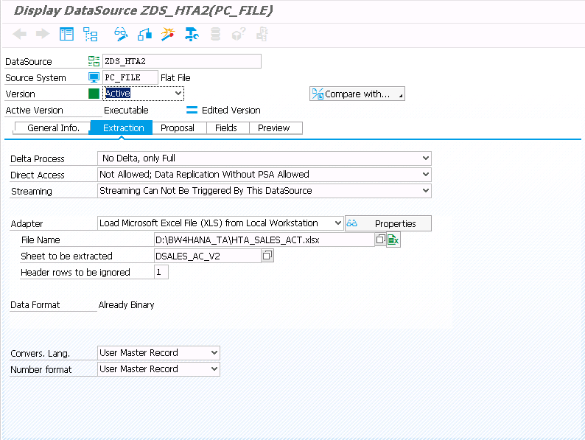

Click the **Proposal** tab and click **Load Example Data**.

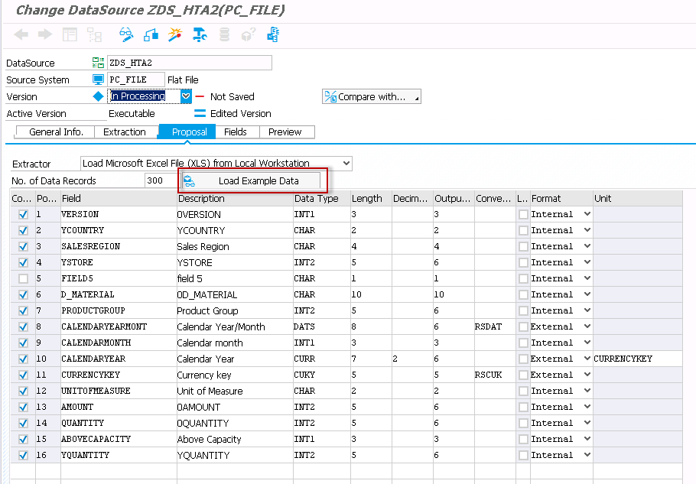

Click the **Fields** tab and change the **Data Type**, **Length**, **Decimal** and Conversion Routines as follows :

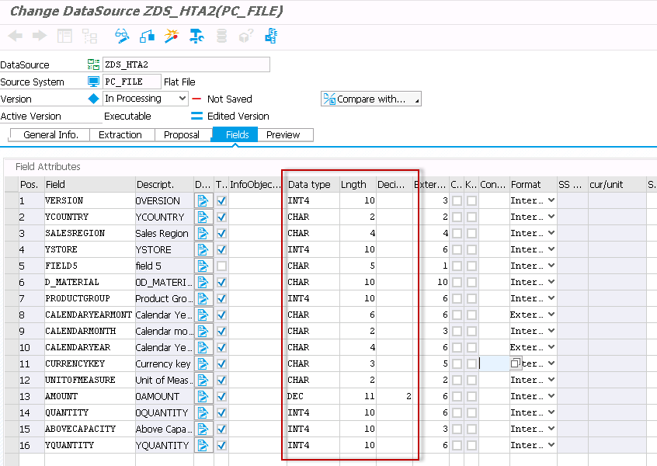

Then click the **Check** to validate and **Activate** button to activate the Data Source.

A warning will appear but click the **Green Check** to ignore this warning.

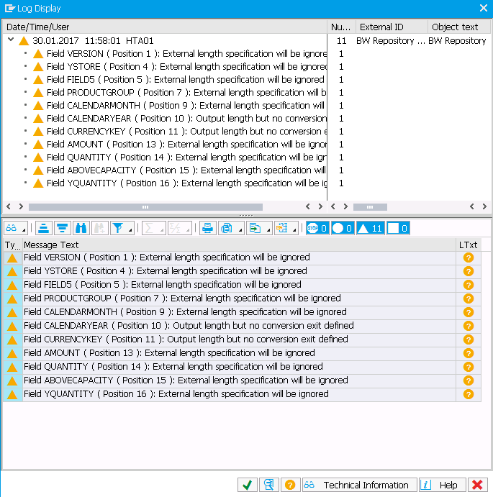

The following message appears at the bottom of the screen



### **Create a new advanced DSO**

Under the same InfoArea **ZHTA01**, Right click on **DataStore Object (advanced)**, select **New** -> **New DataStore Object (advanced)**.

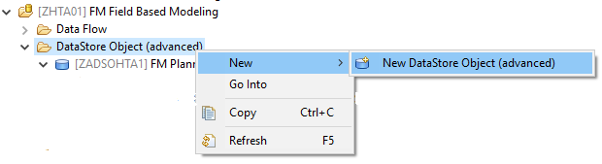

Enter in the Technical Name **ZADSOHTA2** and the Description **FM Actual Data** (step 1)

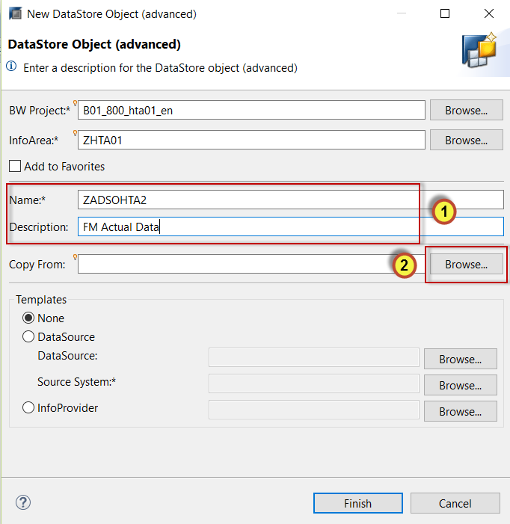

Click the **Browse** button to the right of the **Copy From** field (step 2).

Search for **Z\***and select **ZADSOHTA1** from the list of available ADSO’s.

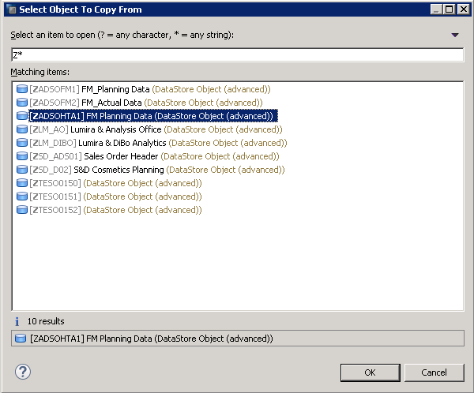

Click **OK.**

Click **Finish** on the **New Datastore Object** screen.

Click **Activate** to activate the Advanced DSO

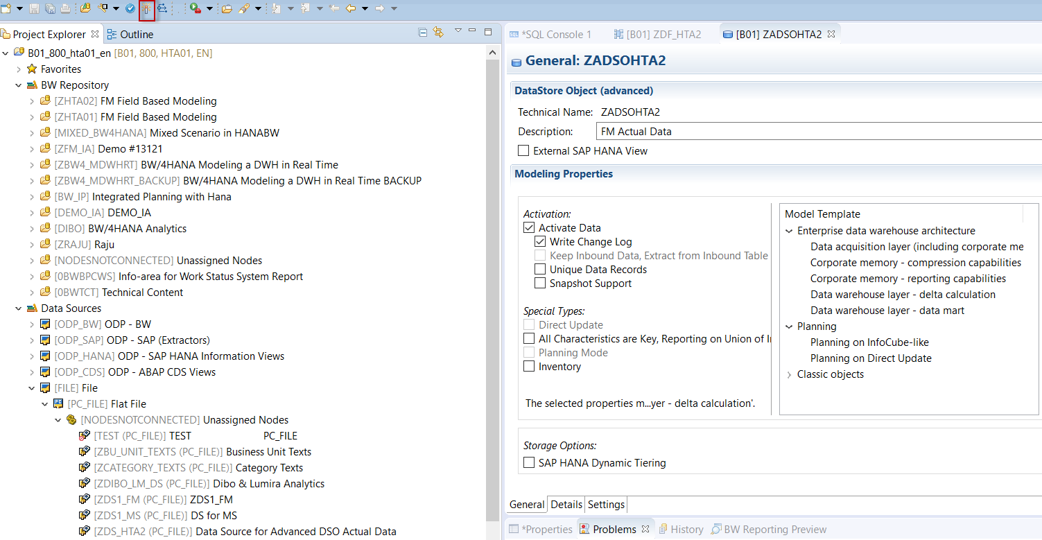

### **Create New Data Flow**

Now we will create a Data Flow to load the data from the Excel File into the Advanced DSO.

Right click the InfoArea **ZHTA01** and choose **New ->** **Data Flow**

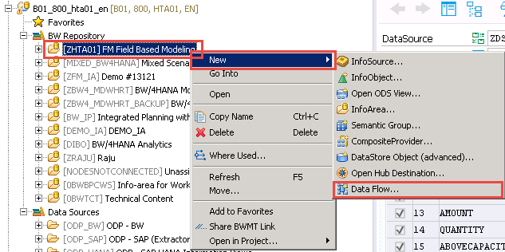

Enter the technical name **ZDF_HTA2** and the Description **FM Data Flow for Planning Data** (step 1)

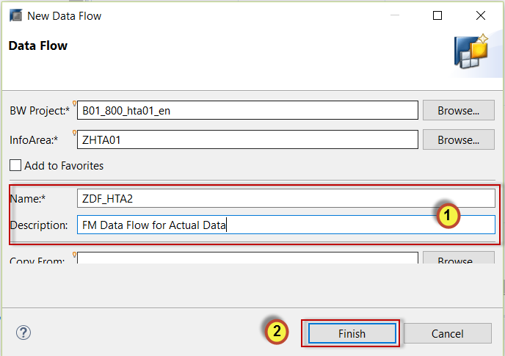

Click **Finish (step 2)**

First we will select the target for our Data Flow.

Select the **DataStore** **Object (advanced)** and drop it on the screen.



Right click on the object and select **Add Object**



Enter **ZADSO** in the search (step 1) and select Advanced DSO **ZADSOHTA2** (step 2).

Click **OK** (step 3).

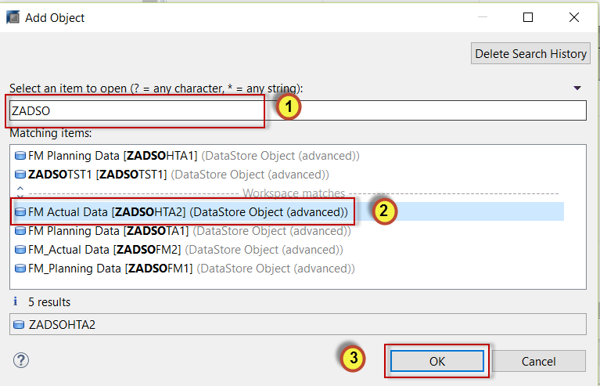

Next we will select the Data Source.

Select the **BW DataSoure** and drop it on the screen.

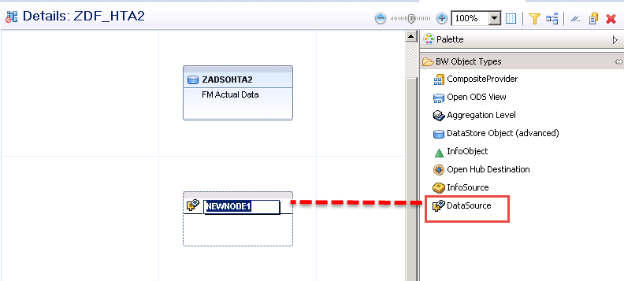

Right click on the object and select **Add Object**



Enter **ZDS_** in the search (step 1) and select DataSource **ZDS_HTA02** (step 2).

Click **OK** (step 3).

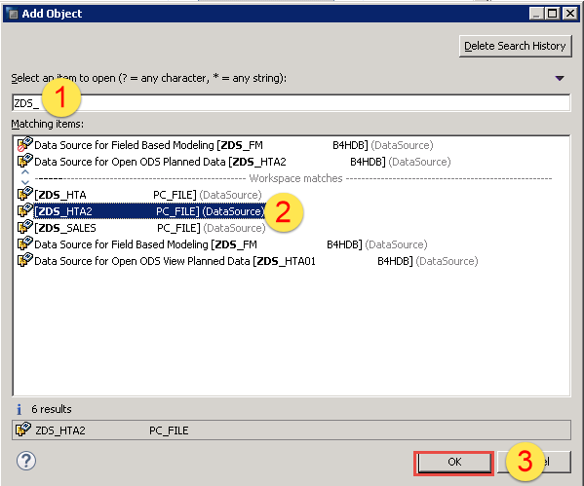

Your Data Flow should look as follows:

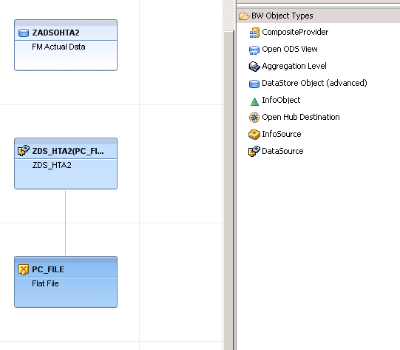

Next we will **link** the source to the target and **create** our transformation.

Hover your cursor over the Data Source **Connection Arrow** (step 1)and drag connection to the AdvancedDSO **ZADSOHTA2** (step 2).

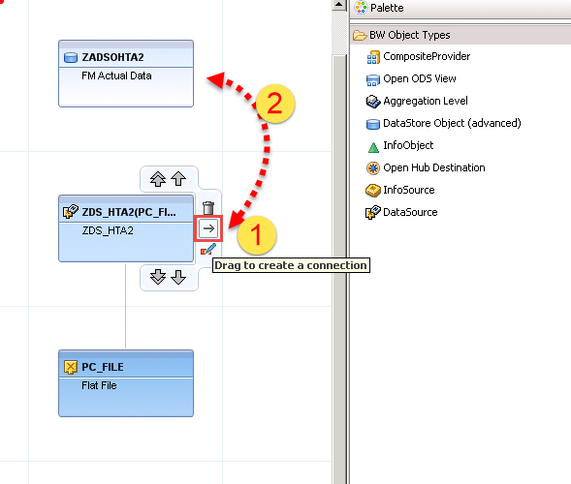

To create the Transformation right-click on ADSO **ZADSOHTA2** (step 1), select **Transformations** (step 2)and **Create transformation RSDS_ZDS_HTA02** (step 3).

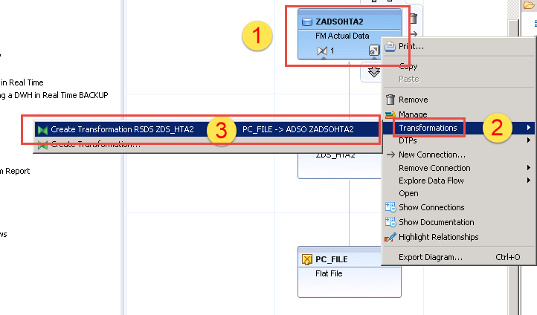

Click on **Create Transformation Check.**

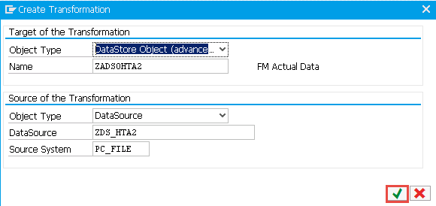

Draw a line from **CALENDARYEARMONTH** in the data source to **CALENDARYEARMONTH** in the Advanced DSO

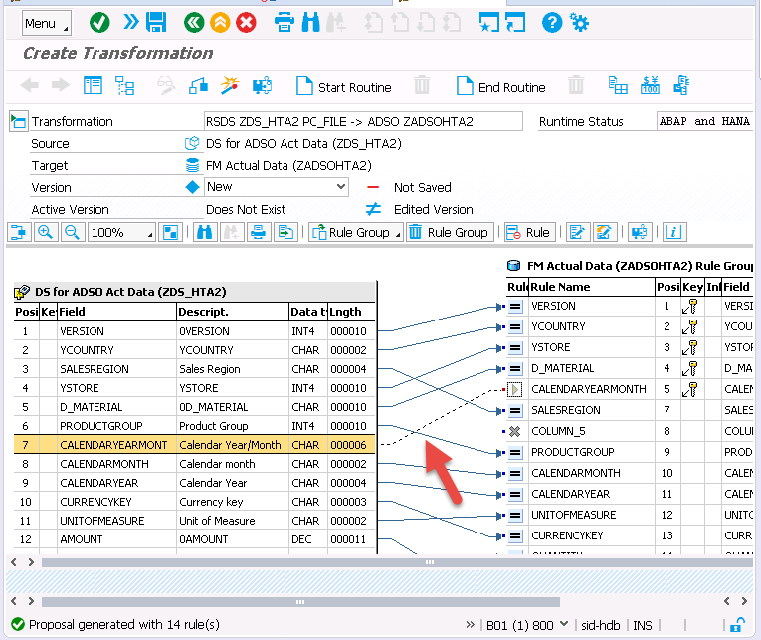

Double click on AMOUNT, and change its Aggregation to **Summation** (step 1).

OR Right-click on AMOUNT and select **Rule Details.**

Click on **Transfer Values** to confirm changes (step 2).

This will allow the summation of Key Figures for duplicate rows in the flat file.

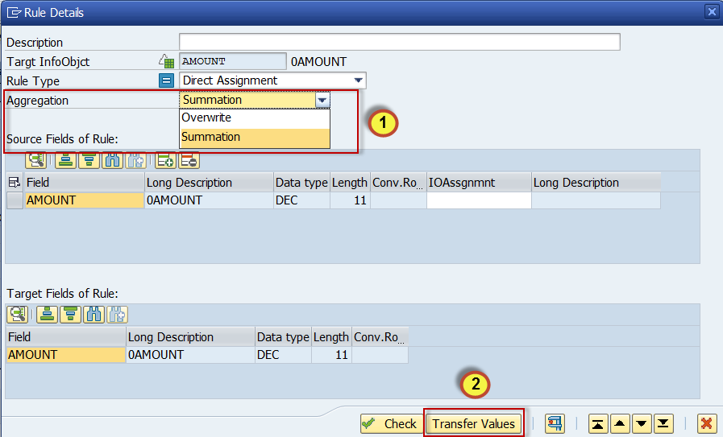

Now change the Aggregation Rule for the other 3 Key Figures too.

**ABOVECAPACITY**

**AMOUNT**

**YQUANTITY**

Keep the remaining selections and click **Activate.**

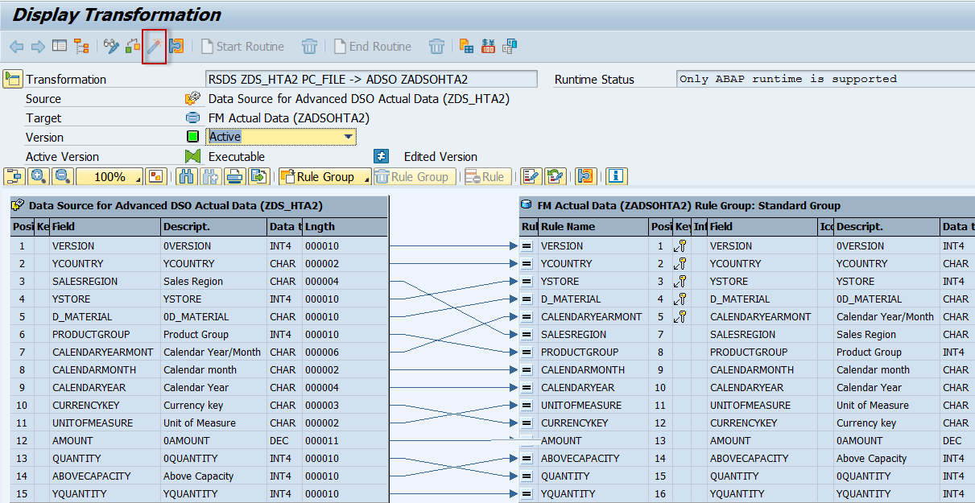

Click **Continue** on the Log Display

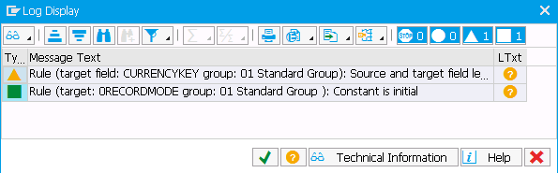

Select the **Data Flow** tab again.

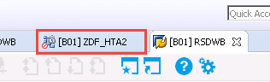

The transformation should now be green and active.

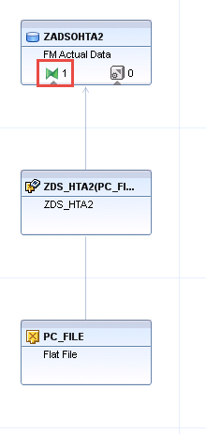

### **Create new DTP to load data**

Within the Data Flow Tab, Right-click on ADSO **ZADSOHTA2** (step 1), select **DTPs** (step 2) and **Create DTP** (step 3).

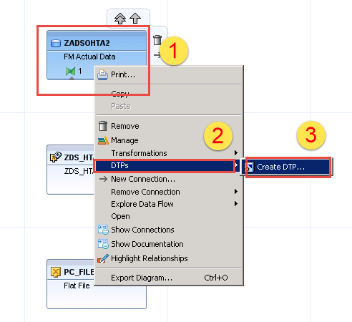

No Need to enter anything in the filter text.

Click on ADSO **ZADSOHTA2** and click **OK.**

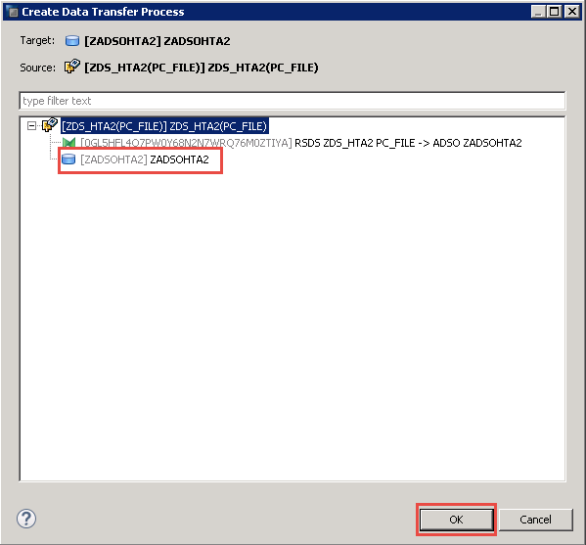

The following pop-up appears

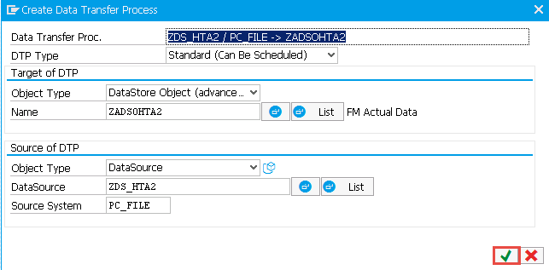

Click **Continue** to continue creating the DTP.

Change the **Package Size** to 100,000 (step 1) then click on **Check** (step 2) and **Activate** (step 3).

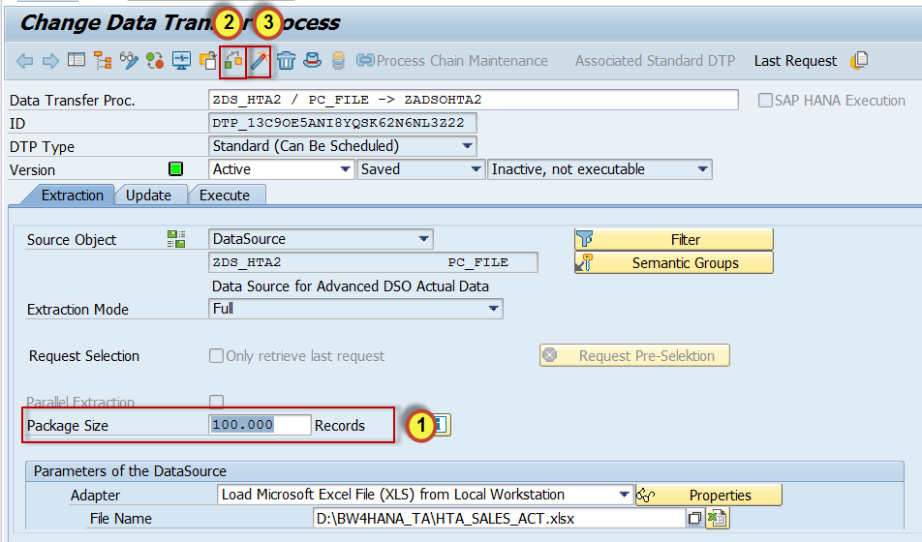

Next we will activate the whole Data Flow.

Click on the **Data Flow** tab (step1) and **Activate** the Data Flow (step 2).

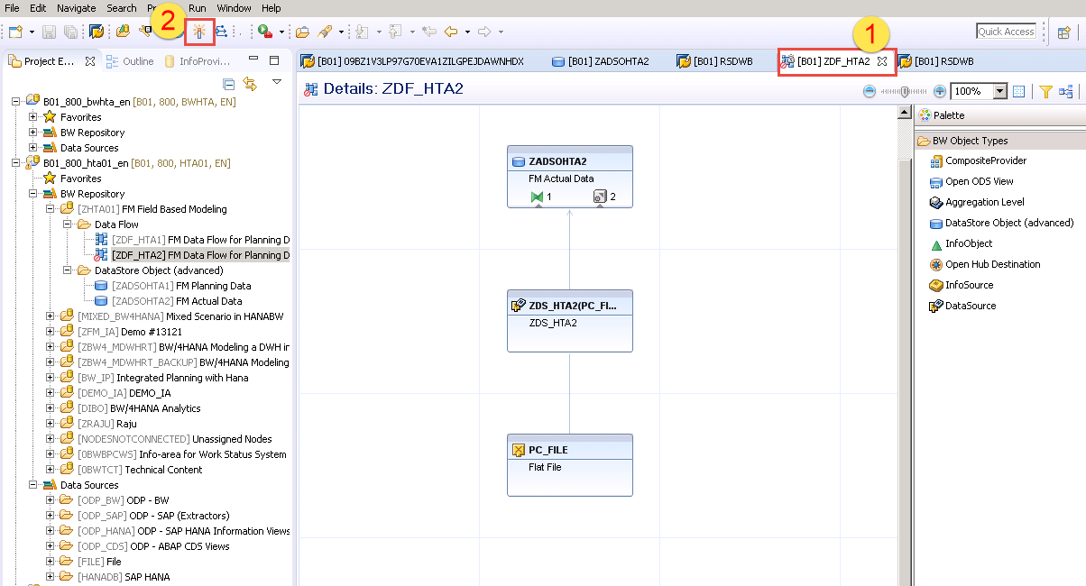

Now we will load data to the ADSO.

Go back to the **DTP** tab (step 1), select the **Execute tab** (step 2) and click **Execute** (step 3) the DTP in the background.

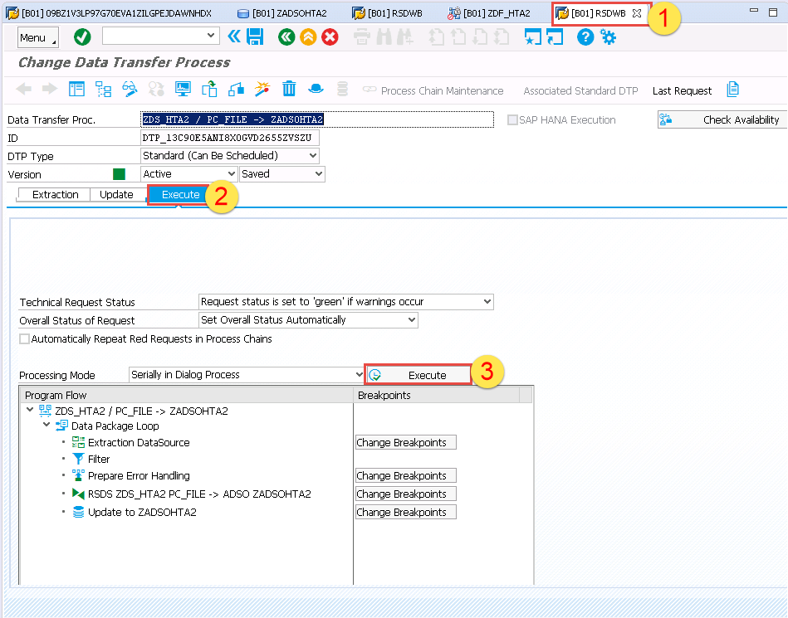

The following pop-up appears.

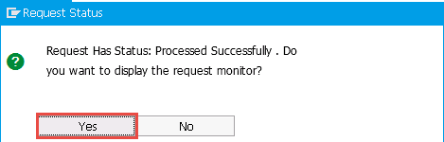

Click **Yes**

One data packages with a total of **99,999** records were processesd.

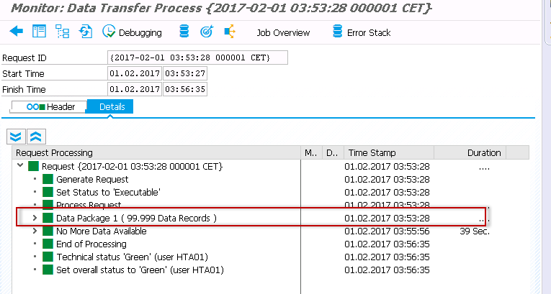

### **View Data**

To view your records go back to the **Data Flow tab** (step 1), right-click on ADSO **ZADSOHTA2** (step 2) and select **Manage** (step 3).

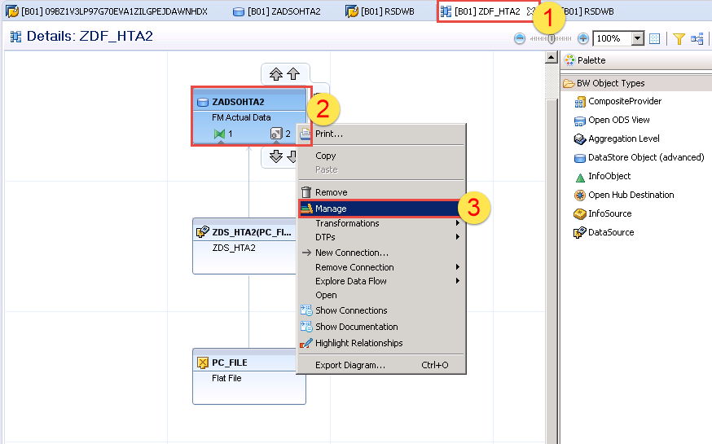

The following screen appears

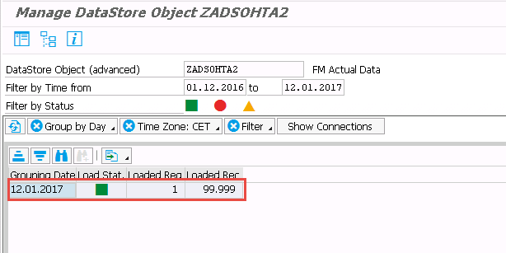

Right-click on request and **Activate** first.

Right-click on the **Load Request** (step 1) and **Display Active Data** (step 2).

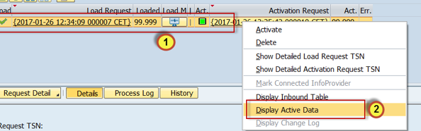

The data is displayed as below:

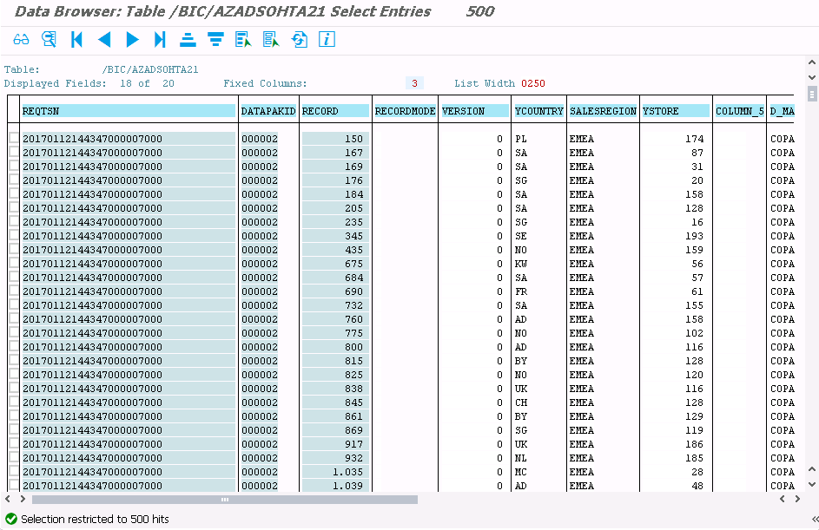

Close all the tab, select **File** (step 1), and select **Close All** (step 2).



# Composite Provider

## Overview

The Composite Provider allows you to join data using Union, Inner, Left & Right Outer Join conditions.

We will focus only on one scenario:

* To combine in a UNION the Actual and Planned data from the previous exercises.

At the conclusion of this exercise you will be able to:

* Create a Composite Provider.

## Create New Composite Provider

Back in the Project Explorer panel, right click on the InfoArea **ZHTA01** select **New-> CompositeProvider…**

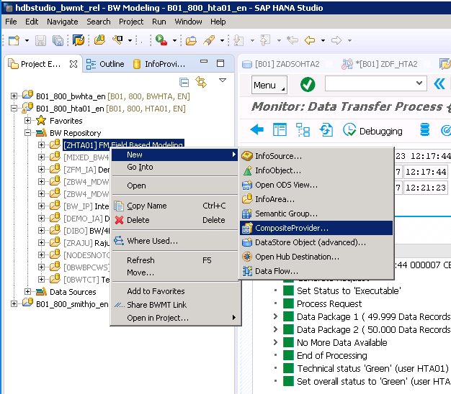

Enter the Technical Name **ZCP_HTA01** and Description **Actual v Planned.**

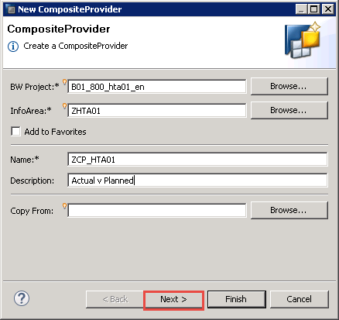

Click **Next.**

In the Union section, click the **Add** button to add Advanced DSOs.

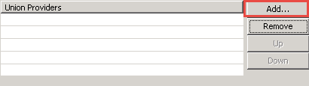

In the search window, type **ZADSO** and select both Advanced DSOs that were created earlier.

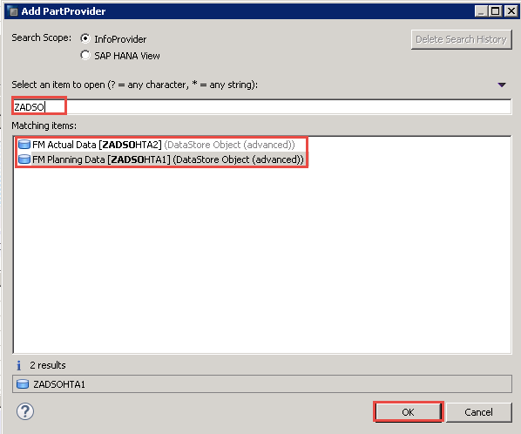

Click the **OK** button

Note that the two selected ADSOs are now in the Union section.

Click the **Finish** button.

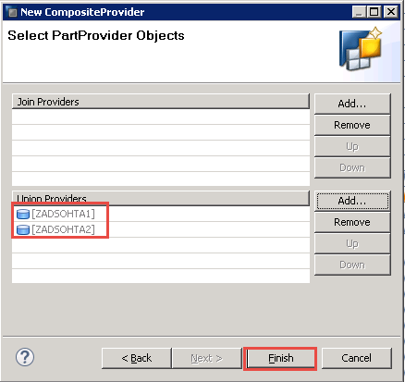

In the **General** Tab, Check the **External SAP HANA View** check box to generate a calculation view in HANA.

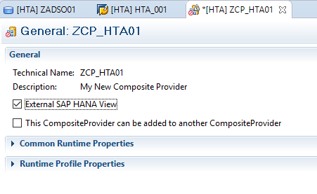

On the bottom of the screen, select the **Scenario** tab.

Click the **expand (+)** button to display all source fields.

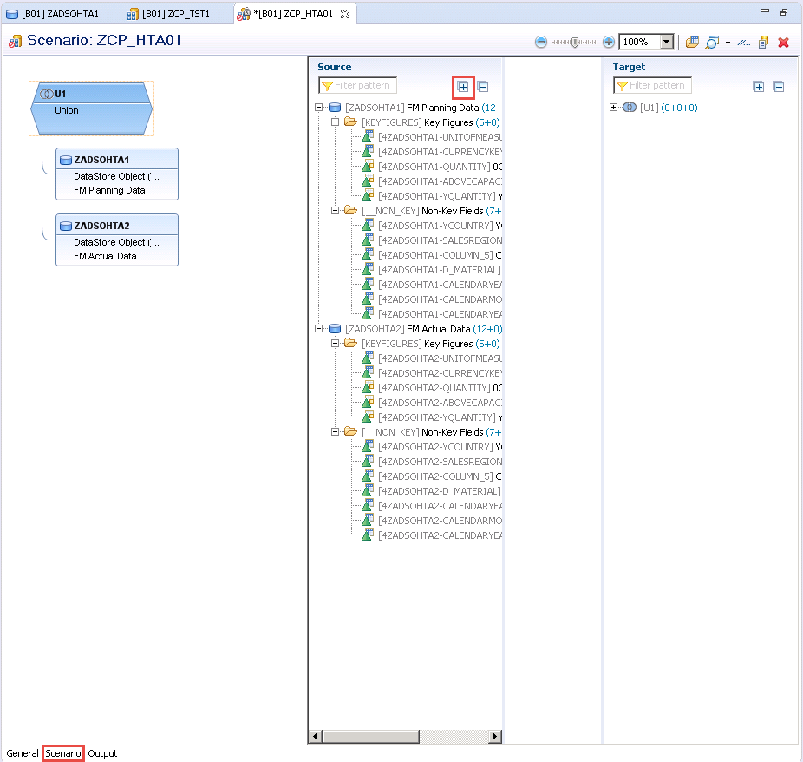

Select all the **KEYFIGURES** fields from **ZADSOHTA1**, right click and choose **Create Assignments.**

Then do the same for **the _NONKEY** fields.

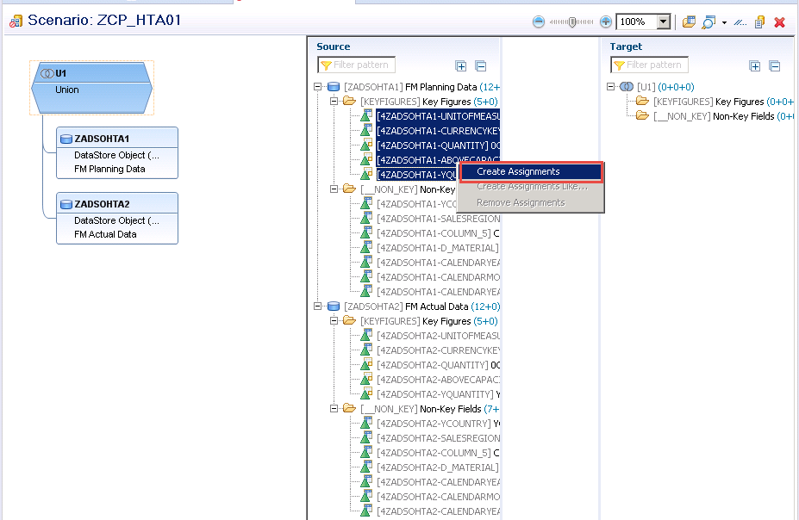

Notice the fields you have selected have now been moved to the Target panel.

Select all the **KEYFIGURES** fields from **ZADSOHTA2**, right click and choose **Create Assignments.**

Then do the same for **the _NONKEY** fields.

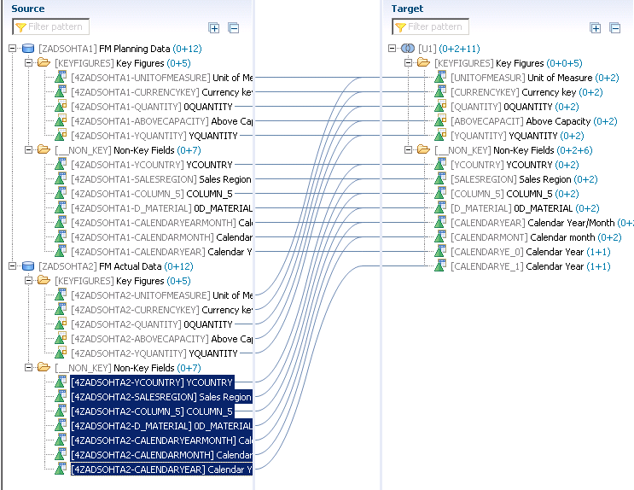

Click the **Output** tab to see output fields of the Composite Provider.

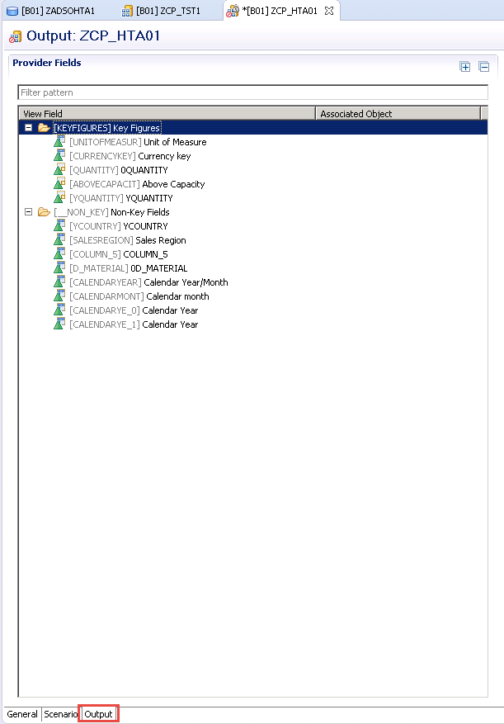

**Activate** the Composite Provider.

This will be used as the base of the next exercise.

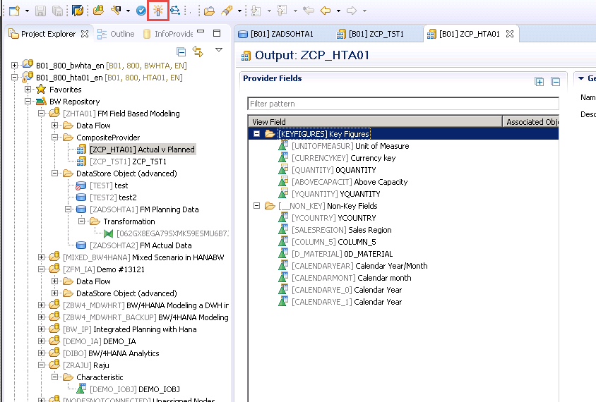

A calculation view is created based on the composite provider.

This can be found by navigating back to the SAP HANA Administration Console (step 1).

Navigate to **Content >> system-local >> bw >> bw2hana >> Calculation Views** (step 2).

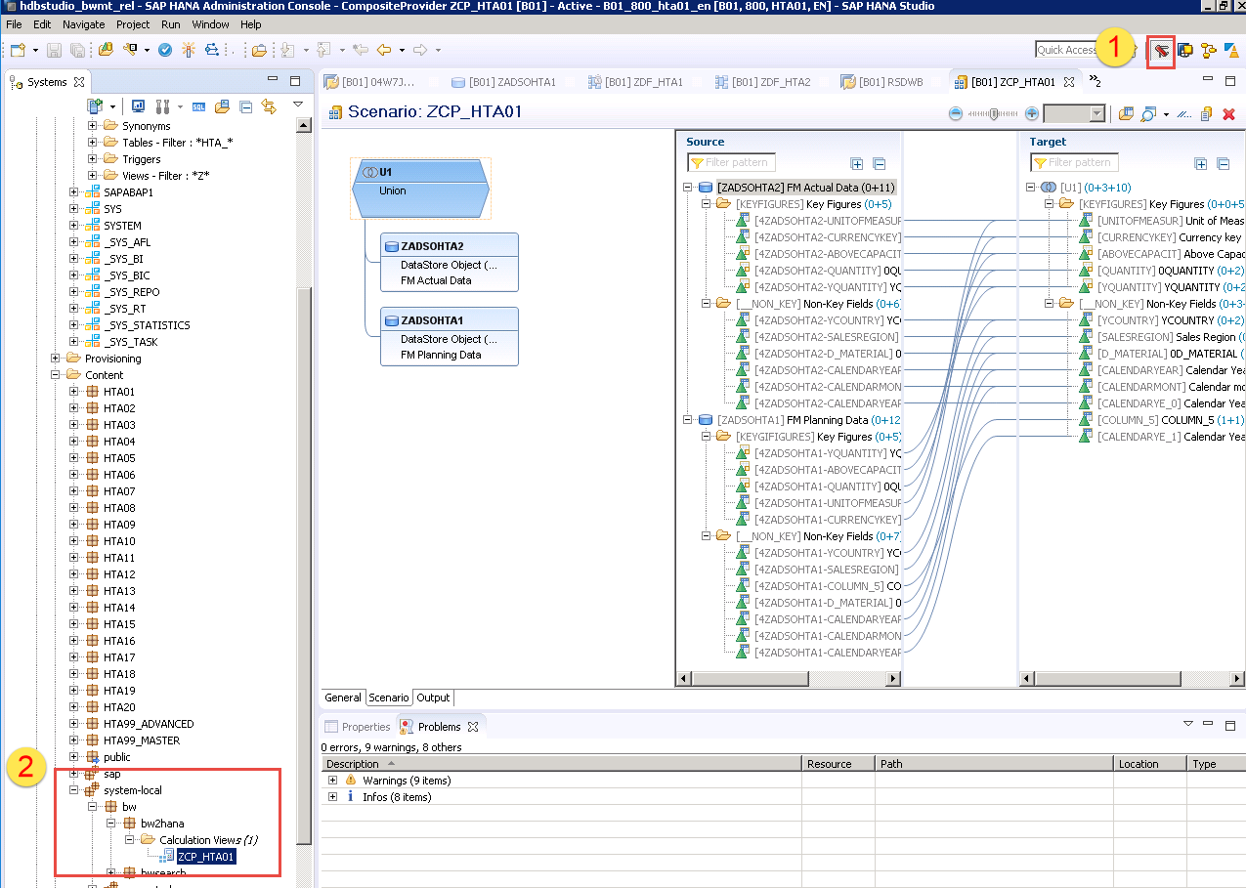

# SAP Business Objects Lumira

## Overview

We will consume our BW/4HANA Composite Provider in SAP Lumira.

At the conclusion of this exercise you will be able to:

* Create a connection to SAP HANA with New Dataset.

## Connect to Data

Launch SAP BusinessObjects Lumira 1.31 from desktop shortcut.

Double – click the **SAP Lumira** icon on the desktop.

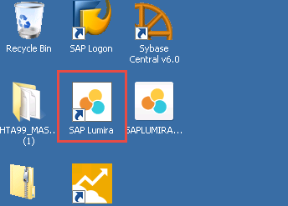

To add a new Document, follow the path **File -> New.**

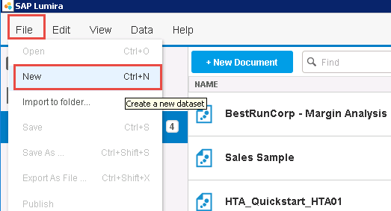

Choose **Connect to SAP HANA** and then click **Next.**

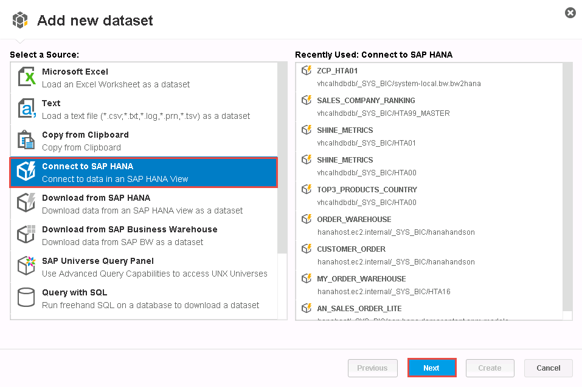

Choose **HANA** from the **Connect to** dropdown (step 1).

Choose the server **vhcalhdbdb** from the Server dropdown (step 2).

The remaining details should be populated automatically (step 3).

Click **Connect** (step 4).

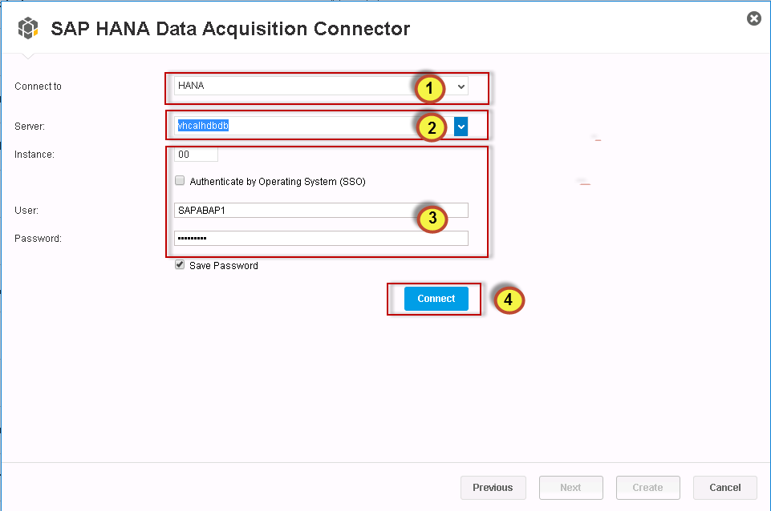

Enter **ZCP** in the Search to find your Composite Provider (Step 1)

Select **ZCP_HTA01** from the list of available views (step 2) and click **Create** (step 3).

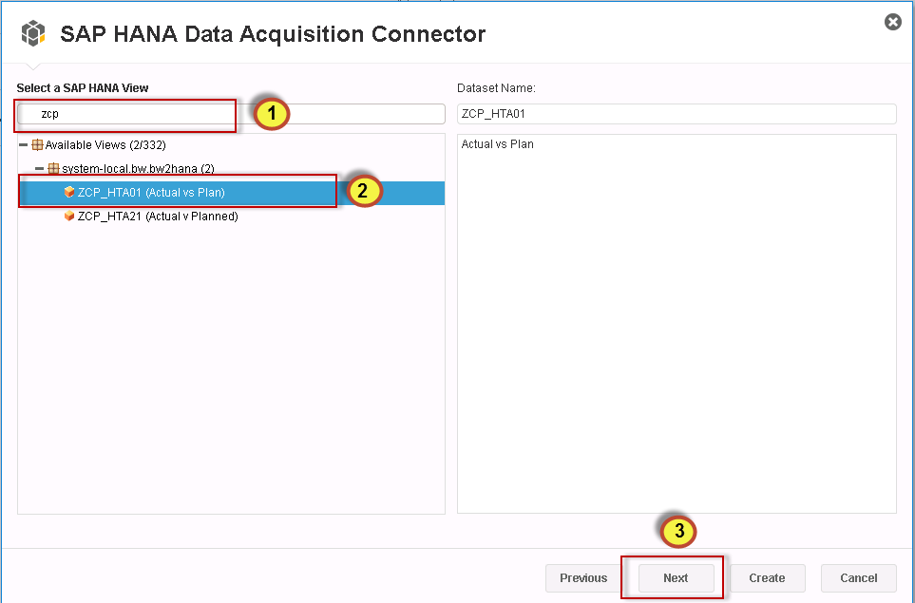

No need to enter data for the **Key Date** so click **OK**.

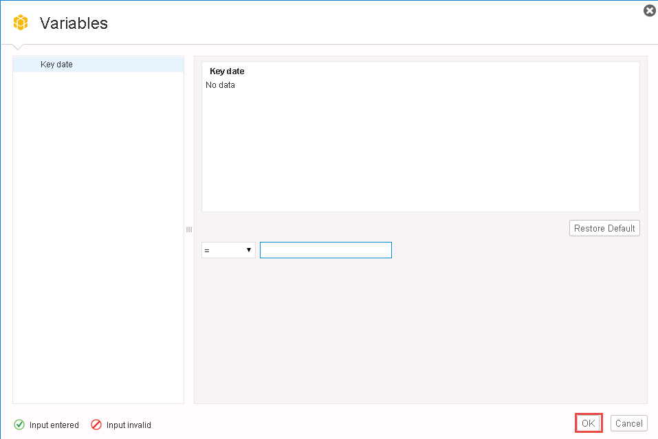

Drag and Drop the I**nfoProvider** from the Dimensions panel into the **Dimensions Color.**

Drag and Drop **0QUANTITY** from the Measures panel into the **Measures X-Axis**.

Drag and Drop **Calendar Year** from the Dimensions Panel into the **Dimensions Y-Axis.**

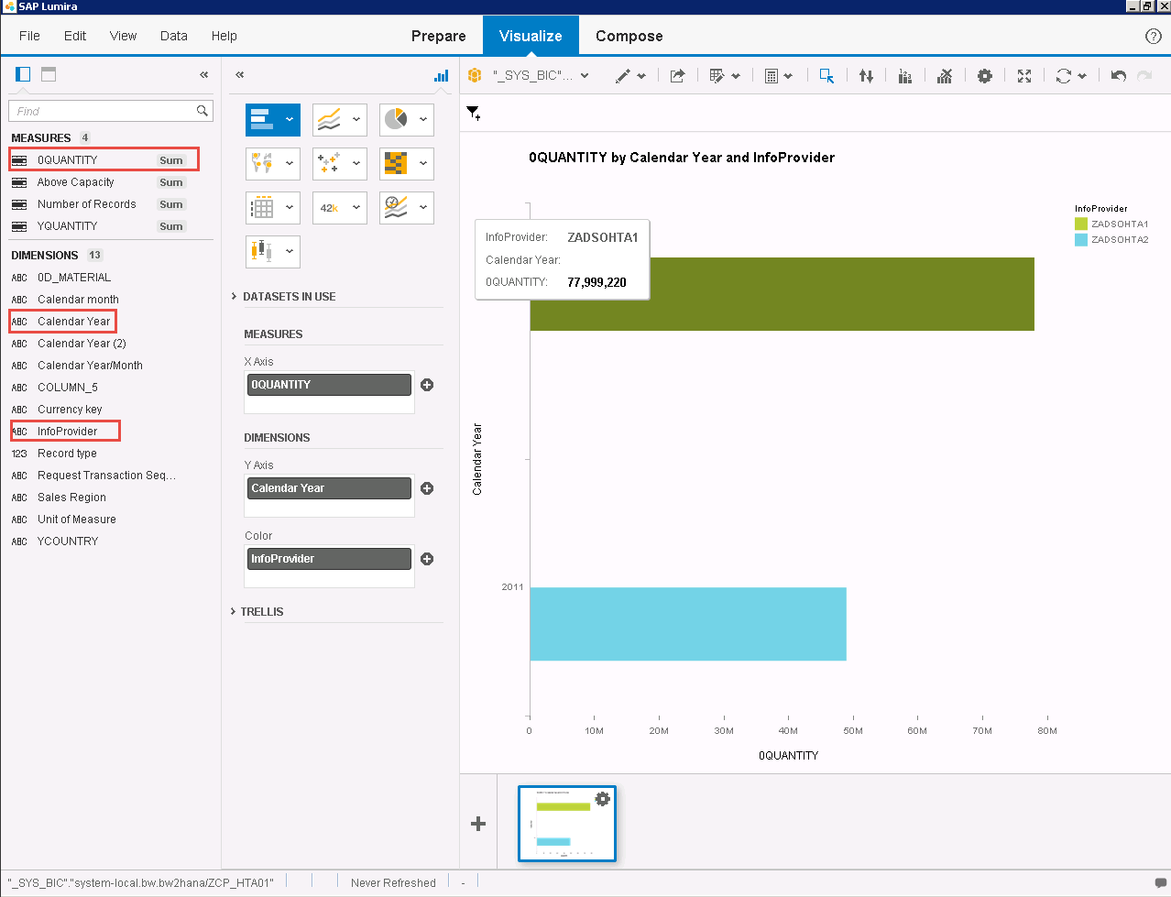

Change the chart type to display a different view of the data.

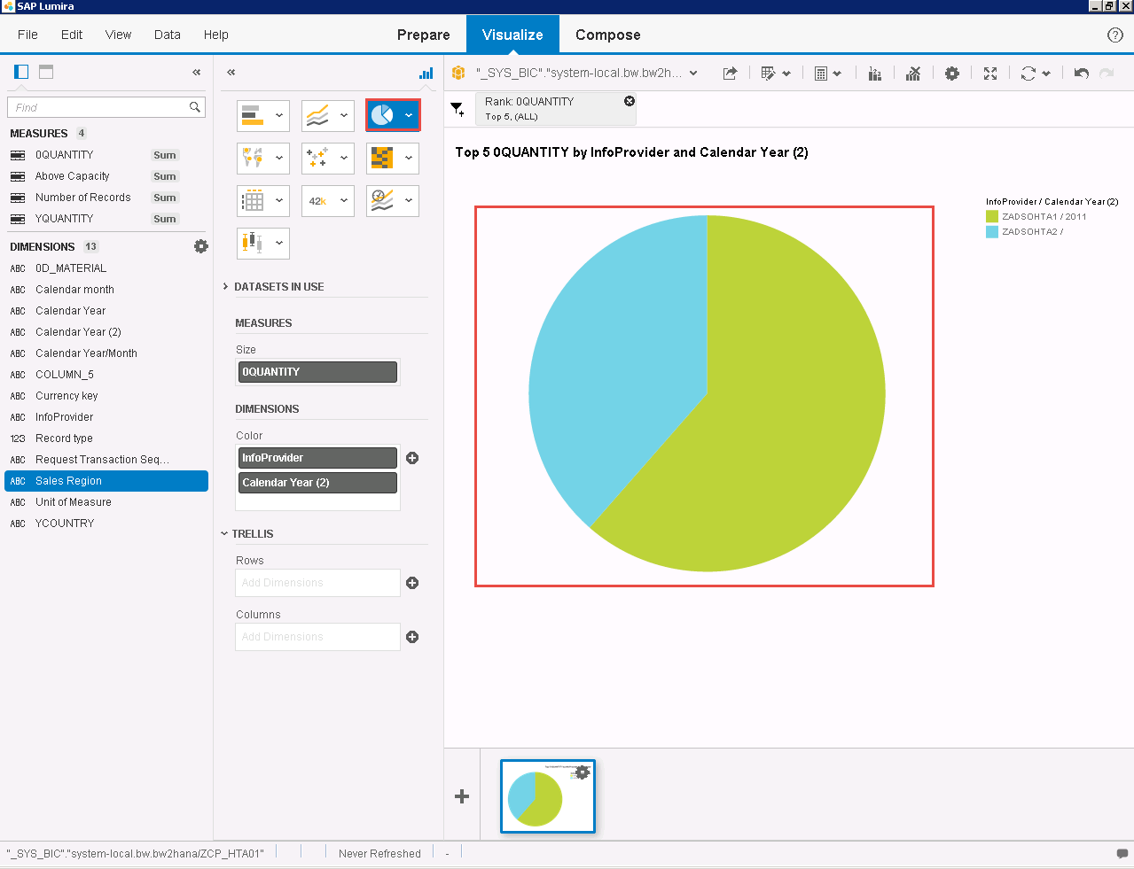

For our exercise we will just **visualize** our data and not **compose** a new Story.